**Background**

The Scarborough Place Street Greening Proposal was developed in response to the principles and recommendations of the [**Urban Forest Strategy**](https://www.melbourne.vic.gov.au/community/greening-the-city/urban-forest/Pages/urban-forest-strategy.aspx), the implementation of the [**Kensington Urban Forest Precinct Plan 2014–2024**](https://www.melbourne.vic.gov.au/SiteCollectionDocuments/UFPP_Kensington_Precinct.pdf) and the community’s support for streets that are green and welcoming, with cooling canopy cover, street gardens, beautiful trees and safe traffic conditions.

Scarborough Place, Kensington currently does not have any street trees or greening, this offers good opportunities for in-road street tree planting with biodiverse garden beds within tree plots.

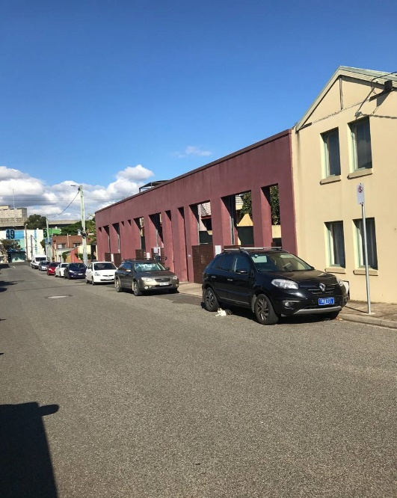

**Image**: Current conditions on Scarborough Place.

The street greening proposal looks to transform the existing streetscape through the introduction of:

* Tree canopy cover — for summer shade, visual impact and climate mitigation
* Street greening to help reduce traffic speed whilst still maintaining two ways of traffic. This then creates a more pleasant environment for those utilising Scarborough Place
* Biodiverse garden beds within passively irrigated tree plots to enhance native ecology, increase permeability and reduce storm water run-off.

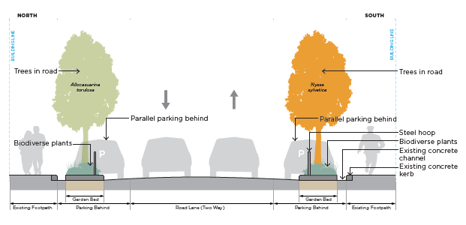

**Cross section:** Proposed improvements for Scarborough Place including street trees and a biodiverse understory garden bed.

**How we engaged**

A Street Greening Proposal was developed and presented for community feedback in March 2021. The consultation encouraged feedback on the proposal from local residents, businesses and property owners in the street and the areas surrounding Scarborough Place.

Consultation ran from 11 March to 1 April 2021. We gathered community insights via:

* an online survey ,
* phone conversations, and
* an onsite visit.

An online workshop was also offered but changed to direct community conversations due to low registrations. The consultation sought to understand community support for the proposed project and any concerns or further improvements that could be made to help finalise the design.

**How we promoted the engagement**

Onsite signage was established at Scarborough Place to reach those who utilised Scarborough Place.

We wrote to all residents, businesses and property owners in Scarborough Place. We also invited them to an information session, to complete our online Participate Melbourne survey, or to contact us directly with any queries or feedback.

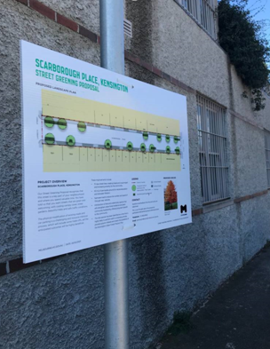

**Image**: Signage on site at Scarborough Place, Kensington during the community consultation period

**Who participated**

In total, ten community members participated during the community consultation period.

Seven responded via the online survey through the Participate Melbourne website. <https://participate.melbourne.vic.gov.au/improving-scarborough-place>

Two participants chose to discuss this project directly by telephoning the project team and one participant lodged their feedback via direct email.

An online information session was scheduled on 17 March 2021. However, due to limited registrations this session was cancelled. Instead, the interested party met with City of Melbourne staff on site at Scarborough Place on the 29 March 2021 to further discuss the Scarborough Place Street Greening Proposal.

**Key topics and ideas**

Respondents were asked:

*“What do you like most about the street greening proposal?”*

When asked to describe the features of the Scarborough Place Street Greening Proposal which appealed most, survey and direct respondents shared their feedback.

The most common feedback received was centred around trees, reduced traffic speed, more green space and an increased sense of community.

**You said**

*“It will look more like a neighbourhood street than a through-way in an industrial estate.”*

*“More trees for shade, birds and carbon capture.”*

*“This street is in great need of greenery and removal of concrete for the health of all residents; human and non-human. The passive irrigation pits and the biodiverse understory are what street trees in this city desperately need - designs that align more closely with the natural ecosystem. There is very little traffic in this street, but the narrowing will make it more friendly for children.”*

**We heard**

* A green streetscape, with canopy trees and understory planting are a priority to attract birds and cool the street.
* The car traffic currently travelling through Scarborough Place makes the street feel unsafe. The introduction of street greening will reduce this.
* A streetscape that encourages community interaction would be something to look forward to.

**Other things we should consider**

Respondents were asked:

*“Is there anything missing that would help inform our planning?”*

When asked whether there was anything further that we should consider in our planning, several suggestions were made to further enhance the design and strengthen the outcomes sought.

**You said**

*“Two things. Permit parking! Car parking during weekdays is becoming more and more difficult so permit parking has to be introduced. Cars from the childcare centre, restaurant and Stubbs Street businesses mean the street is overcrowded and leads to dangerous parking.”*

*“Would prefer to see Australian natives and maybe evergreen trees as part of the design. And understand that there will be a reduction in parking but because of the local businesses in Parsons, Stubbs and Scarborough streets, residential permit parking should be introduced on Scarborough Place AND Lambeth Street. Maybe even parking time restrictions.”*

**We heard**

* Residents’ ability to park vehicles close to their property remains a
* **We heard**

**We heard**

**We heard**

* Residents’ ability to park vehicles close to their property remains a priority, and they do not want to lose any more parking places than necessary.
* There is support for evergreen Australian native trees.
* Concerns for loss of business.

**How your feedback has influenced our proposal**

Based on your feedback, we have updated our street greening proposal, to:

* Introduce an Australian native evergreen tree *- Allocasuarina torulosa*, this species will contribute to ecological connectivity across the city.
* Review the car parking proposition in Scarborough Place to ensure that no parking spaces are removed unnecessarily and identified additional potential car parking locations.
* Explore whether there is community support for resident priority car parking along Scarborough Place.
* Introduce understory and tree plantings that will slow down through-traffic.
* Maintain the current outdoor on street dining area as required.

**Next steps**

We have updated the Scarborough Place Street Greening Plan to reflect the suggestions from this round of community consultation.

Our Traffic team will explore possible proposed parking changes on Scarborough Place in response to the feedback. Further community input will be invited on the possible introduction of parking changes and a letter will be provided to gauge support for the introduction of restricted car parking on Scarborough Place.

We will continue to refine the Scarborough Place Street Greening Plan into something that can be built and implemented. Landscape architects, civil engineers, traffic engineers and horticulturalists will also begin their designs. Funding has been allocated to commence construction by the end of the year.

We will notify all affected households and businesses of expected construction timelines, road closures, tree removals or other disruptions. Follow the <https://participate.melbourne.vic.gov.au/improving-scarborough-place> page to receive online notifications as the project meets progressive milestones.

Should you have questions about this exciting project, you can contact Erica Read, Project Officer, Parks and City Greening on 9658 8421 or emailing [erica.read@melbourne.vic.gov.au](mailto:erica.read@melbourne.vic.gov.au).