
Draft Annual Plan
2022-2023
Purpose of this document
This plan describes the key activities the Council will undertake in 2022–23 in order to make progress towards its commitments in the four-year Council Plan 2021–25. It should be read in conjunction with the Council Plan 2021–25 which was developed with the community through a process of deliberative engagement and outlines the Council’s vision, strategic objectives, priorities, major initiatives and measures of success. This plan represents a companion document to the Budget 202223 which outlines how the Council will resource its activities over the financial year.
Acknowledgement of Traditional Owners
The City of Melbourne respectfully acknowledges the Traditional Owners of the land we govern, the Wurundjeri Woi Wurrung and Bunurong Boon Wurrung peoples of the Eastern Kulin and pays respect to their Elders past, present and emerging.
We acknowledge and honour the unbroken spiritual, cultural and political connection the Wurundjeri, Bunurong, Dja Dja Wurrung, Taungurung and Wadawurrung peoples of the Eastern Kulin have to this unique place for more than 2000 generations.
We are committed to our reconciliation journey, because at its heart, reconciliation is about strengthening relationships between Aboriginal and non-Aboriginal peoples, for the benefit of all Victorians.
Contents
Forward 5
Message from the Lord Mayor 5
Message from the Chief Executive Officer 5
Facts about Melbourne 6
Resident population 6
Economic environment 6
Built and natural environment 6
Health and wellbeing status 6
Social and cultural environment 7
References 7
Municipal overview 8
Neighbourhood map 8
Council 2020–24 and councillor profiles 9
Integrated Planning and Reporting Framework 10
10-year perspective 10
Four-year perspective 10
Annual perspective 11
Community Vision 11
Council’s Strategic Objectives 12
Our program of work for 2022–23 14
Economy of the Future 14
Our priorities 14
Major initiatives 15
Major initiative 1 15
Major initiative 2 16
Major initiative 3 17
Major initiative 4 19
Major initiative 5 20
Major initiative 6 21
Major initiative 7 22
Major initiative 8 23
Major initiative 9 24
Major initiative 10 25
Major initiative 11 26
Melbourne’s Unique Identity and Place 27
Our priorities 27
Major initiatives 28
Major initiative 12 28
Major initiative 13 29
Major initiative 14 30
Major initiative 15 31
Major initiative 16 32
Major initiative 17 33
Major initiative 18 34
Major initiative 19 35
Major initiative 20 36
Major initiative 21 37
Major initiative 22 38
Aboriginal Melbourne 39
Our priorities 39
Major initiatives 40
Major initiative 23 40
Major initiative 24 41
Major initiative 25 42
Major initiative 26 43
Major initiative 27 44
Climate and Biodiversity Emergency 45
Our priorities 45
Major initiatives 46
Major initiative 28 46
Major initiative 29 47
Major initiative 30 48
Major initiative 31 49
Major initiative 32 50
Major initiative 33 51
Major initiative 34 52
Major initiative 35 53
Access and Affordability 54
Our priorities 54
Major initiatives 55
Major initiative 36 55
Major initiative 37 56
Major initiative 38 57
Major initiative 39 58
Major initiative 40 59
Major initiative 41 60
Major initiative 42 61
Major initiative 43 62
Major initiative 44 63
Safety and Wellbeing 64
Our priorities 64
Major initiatives 65
Major initiative 45 65
Major initiative 46 66
Major initiative 47 67
Major initiative 48 68
Major initiative 49 69
Major initiative 50 70
Major initiative 51 71
Major initiative 52 72

Forward

Message from the Lord Mayor
Melbourne is fortified by its experiences over the pandemic, and as a result we’re achieving braver and bolder outcomes for our community, economy and environment.
As a council, we continue to improve and deliver exceptional services for our residents and ratepayers as we embark on this, our second year of our four-year Council Plan, supported by our Budget 2022–23.
Our focus remains on attracting talent, students, investors, business owners, visitors, and residents.
We are a city for people and possibilities.
Our forecasts suggest we will exceed pre-pandemic levels of workers, residents and students and grow our gross local product and city economy to $150 billion by 2031.
In this year’s Annual Plan, I particularly note the following projects:
We will harness our community’s passion to support rough sleepers by securing more funding for our $20 million landmark Make Room initiative.
The first milestone in our $300 million Greenline plan is complete, and we look ahead to the next phases, which will see a stunning four-kilometre promenade created along the north bank of our Yarra River – Birrarung.
Finally, Power Melbourne continues to garner interest from partners to create a network of mid-scale batteries across the city that will encourage greater uptake of renewables and see us become a city powered by 100 per cent renewable energy by 2030, and reach zero net emissions by 2040.
The momentum is building for another big year of growth and extraordinary outcomes for Melbourne.
Sally Capp
Lord Mayor

Message from the Chief Executive Officer
Melbourne’s economic recovery grows ever stronger and this Annual Plan embeds our commitment to the community’s aspirations and priorities.
While the effects of the pandemic linger in some sectors, we continue to support our community as we move into the second year of our four-year Council Plan. Our staff go above and beyond in delivering essential services and they are the welcoming face of many of our creative initiatives such as pop-up libraries in surprising locations, and events that support international students.
The business community has been well supported by our Business Concierge Service which will continue to deliver timely advice. The city continues to reactivate, with pedestrian numbers at 85 per cent of pre-COVID levels. To ensure Melbourne is in great shape, a thorough city cleaning and graffiti blitz has been underway.
I’m proud that our staff work to ensure Melbourne is an inclusive and accessible city. That’s why we continue to upgrade sports facilities for women, and embed gender equity principles in our organisation.
Importantly, we collaborate and we listen. We recognise the unique needs of different neighbourhoods. We partner with industry and international contacts to spark innovation and deliver renewable energy initiatives. In consultation with Aboriginal communities, we’ll establish a Stolen Generations memorial site, with planning beginning this year.
May I thank City of Melbourne councillors, staff and stakeholders, together with our partners in business and the community. I look forward to all that we can achieve together in the second year of our Council Plan.
Justin Hanney
Chief Executive Officer

Facts about Melbourne
The diversity of the municipality is evident in our demographic and urban profile:

Resident population
- 169,860 residents
- 910,800 people live, work, study or socialise in the municipality
- 468 Aboriginal and/or Torres Strait Islander peoples
- 1.7% live with a disability
- 49% males
- 51% females
- 56% born overseas
- 48% speak a language other than English
- 87,300 overseas higher education students
- 1,653 same-sex couple households
- 295 people experiencing homelessness
- 119 people sleeping rough

Economic environment
- Melbourne contributes 20.7% to the Victorian economy
- 15,000 businesses
- 458,400 jobs
- 5.5% unemployment rate
- 32% of households experience rental and mortgage stress
- 33.3% experience food insecurity
- 19% retail vacancy rate (new)

Built and natural environment
- 59.2% resident trips made by public transport, cycling or walking
- 61.9% grow and consume their own food at home
- 23.3% tree canopy cover in the public realm
- 22.5 tonnes of greenhouse gas emissions per capita, an annual decrease of 17%
- 0.3 tonnes of landfill waste per household
- 136 kilolitres from alternative water sources used to meet municipal needs

Health and wellbeing status
- 22% experience high or very high psychological distress in their day-to-day lives
- 22% have been diagnosed with depression or anxiety
- 15% have sought help from a mental health professional
- 93.6% of adults do not eat enough fruit and vegetables
- 54.7% of adults do not engage in sufficient physical activity
- 22% sit for 8+ hours on an average weekday
- 12.5% currently smoke
- 929 per 100,000 reported incidences of family violence

Social and cultural environment
- 63.2% feel a sense of belonging to their community
- 95.7% believe the relationship with Aboriginal people is important
- 20.3% participate in arts and cultural activities
- 78.9% feel safe during the day
- 47.2% feel safe at night

References
- Australian Bureau of Statistics 2016
- City of Melbourne Annual Report 2017, 2021
- City of Melbourne by Name List 2022
- City of Melbourne Community Indicator Survey 2021
- Crime Statistics Agency 2020
- Victorian Integrated Survey of Travel and Activity 2018
- Victorian Population Health Survey 2017

Municipal overview
Melbourne is a dynamic municipality with a broad set of neighbourhoods, each with its own unique characteristics and needs – from densely populated urban environments, such as the central business district, to more residential areas, such as Kensington, Carlton and South Yarra.

Neighbourhood map
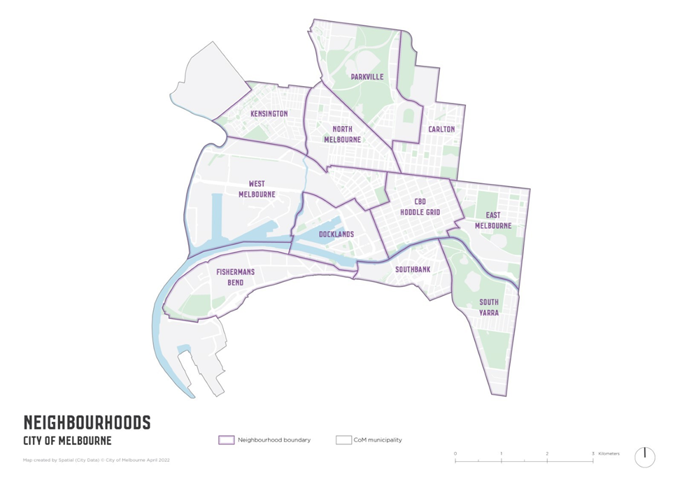
Recognising the unique strengths, needs and outlooks of each pocket of Melbourne, the City of Melbourne is taking a stronger neighbourhood focus – capturing and connecting with the specific aspirations and priorities of our local communities.
While we’re all Melburnians at heart, the support and services naturally differ for Carlton, Kensington, North Melbourne, West Melbourne, East Melbourne, Parkville, Docklands, Southbank, South Yarra and the CBD – taking into account the different demographics, opportunities and challenges.
Beginning with Kensington and the CBD, we are progressively identifying a set of neighbourhood priorities for each area of the municipality, based on what we are hearing from local communities about their aspirations.
To find out more about the City of Melbourne’s neighbourhood planning process, go to City of Melbourne.

Council 2020–24 and councillor profiles
Lord Mayor
Sally Capp
03 9658 9658
lordmayor@melbourne.vic.gov.au
Deputy Lord Mayor
Nicholas Reece
03 9658 9704
nicholas.reece@melbourne.vic.gov.au
Councillor
Dr Olivia Ball
03 9658 9086
olivia.ball@melbourne.vic.gov.au
Councillor
Roshena Campbell
03 9658 9043
roshena.campbell@melbourne.vic.gov.au
Councillor
Jason Chang
03 9658 9038
jason.chang@melbourne.vic.gov.au
Councillor
Elizabeth Mary Doidge
03 9658 9636
ElizabethMary.Doidge@melbourne.vic.gov.au
Councillor
Davydd Griffiths
03 9658 9056
davydd.griffiths@melbourne.vic.gov.au
Councillor
Jamal Hakim
03 9658 8580
jamal.hakim@melbourne.vic.gov.au
Councillor
Philip Le Liu
03 9658 9630
philip.leliu@melbourne.vic.gov.au
Councillor
Rohan Leppert
03 9658 9051
rohan.leppert@melbourne.vic.gov.au
Councillor
Kevin Louey
03 9658 9170
kevin.louey@melbourne.vic.gov.au
Postal address for all councillors
City of Melbourne
GPO Box 1603
Melbourne VIC 3001

Integrated Planning and Reporting Framework
Our planning framework describes how the City of Melbourne strives to realise the community’s aspirations through a cascading hierarchy of long-term and medium-term plans, resourcing decisions, and the continual process of implementation, monitoring and review.
The suite of documents illustrated in the framework below outlines the processes and decisions the City of Melbourne undertakes in the interests of the municipality – with community input, in accordance with the Local Government Act 2020 and other key legislation.
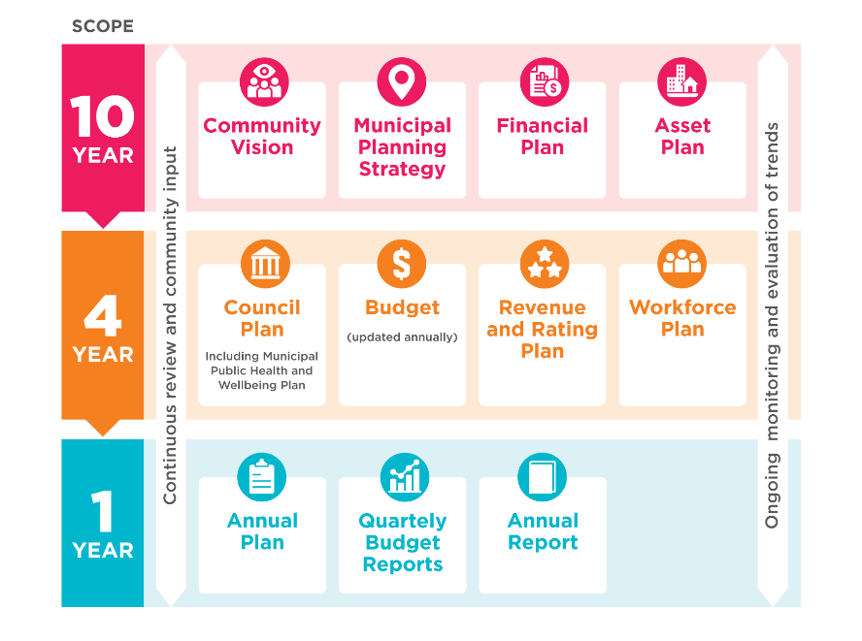

10-year perspective
The Community Vision represents the community’s aspirations for Melbourne over a 10-year period. It guides everything the Council does, including all strategic decision-making and collaboration with key partners, stakeholders and the community. The Community Vision is incorporated into the Council Plan.
The Municipal Planning Strategy guides long-term land use and development to achieve desired social, economic and environmental outcomes for the city. It supports the state-wide Melbourne Planning Scheme that governs the use, development and protection of municipal land.
The Financial Plan provides a 10-year view of the Council’s resources and sources of funding and how those resources will be applied across services, operations, capital investments and assets.
The Asset Plan outlines the Council’s high-level asset management priorities over a 10-year period and how the Council proposes to manage its portfolio of assets.

Four-year perspective
The Council Plan is the Council’s four-year commitment to the community. Guided by the Community Vision, it outlines how the Council will strive towards the community’s aspirations and how it will measure success.
The Health and Wellbeing Plan is integrated into the Council Plan and shapes how we work to protect and promote the health and wellbeing of individuals and the community we serve. To find out more about the Council's health and wellbeing focus areas over four years and what we will do to achieve improved health and wellbeing outcomes, see our Health and Wellbeing Action Plan at City of Melbourne website.
The Budget details the City of Melbourne’s annualised activities over the next four years and the resources required to deliver the Council Plan.
The Revenue and Rating Plan describes how the Council will generate income to deliver on the Council Plan, programs and services and capital works commitments.
The Workforce Plan describes the anticipated staffing requirements for a period of at least four years and the organisational structure. The Chief Executive Officer is responsible for establishing and maintaining an organisation structure for the Council and is also responsible for all staffing matters.

Annual perspective
The Annual Plan (this document) provides a snapshot of what the Council will do over a 12-month period to make progress towards the major initiatives it has committed to delivering in the four-year Council Plan.
The Council’s progress on implementation of the Council Plan, Health and Wellbeing Plan and the Budget is presented in the Annual Report.
During each financial year, a Quarterly Budget Report is prepared for the Council on actual and budgeted results and variances.

Community Vision
The City of Melbourne is a city of possibility.
Where the world meets and the extraordinary happens.

Council’s Strategic Objectives
In response to the Community Vision, Council developed six strategic objectives for its four-year Council Plan 2021–25. These are outlined below and set the direction for the Council’s term. Our vision for Melbourne as a ‘city of possibility’ anchors and connects these objectives to deliver real outcomes for the community. To read more about our Council Plan, see City of Melbourne website.
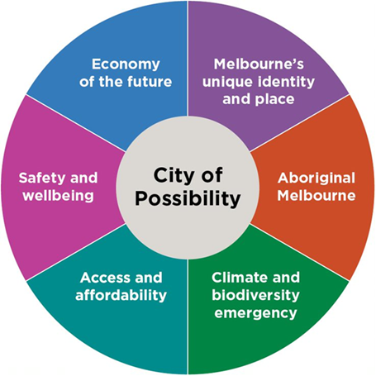
The work of the Council to achieve the Community Vision and strategic objectives is set out in a series of major initiatives it is undertaking during its four-year term. Each year, as part of its annual program of work, the Council considers how it will best deliver the major initiatives through a series of key activities, which is outlined in this Annual Plan.
The major initiatives are described in greater detail under each strategic objective chapter on pages x to x, including:
- the key activities and milestones we will deliver in 2022–23
- the outcomes we seek to achieve as a result of delivering this work
- the indicators of success in our Council Plan this work will contribute towards
- the Sustainable Development Goals (see next section) this work will support.
Sustainable Development Goals
In 2015, the Australian Government, together with all United Nations member states, committed to an overarching framework for global development, titled Transforming Our World: The 2030 Agenda for Sustainable Development. It sets out 17 ambitious goals supported by 169 targets and 231 indicators designed to measure progress at a national level.
Action on the Sustainable Development Goals (SDGs) is primarily directed at a national level. However, at the City of Melbourne, we recognise all levels of government must play a role to create change.
Recognising the role a global city like Melbourne has in helping achieve the SDGs, we have reflected in this document how each of the major initiatives the Council is delivering on as part of the Council Plan 2021-2025 relate to particular SDG targets.
Separately, in a first for Australia, the City of Melbourne has conducted a Voluntary Local Review of Melbourne’s progress against the SDGs. For more information about this, see our website.
17 Sustainable Development Goals
Sustainable Development Goal number 1 – No Poverty
Sustainable Development Goal number 2 – Zero Hunger
Sustainable Development Goal number 3 – Good Health and Well-being
Sustainable Development Goal number 4 – Quality Education
Sustainable Development Goal number 5 – Gender Equality
Sustainable Development Goal number 6 – Clean Water and sanitation
Sustainable Development Goal number 7 – Affordable and Clean Energy
Sustainable Development Goal number 8 – Decent Work and Economic Growth
Sustainable Development Goal number 9 – Industry, Innovation and Infrastructure
Sustainable Development Goal number 10 – Reduced Inequalities
Sustainable Development Goal number 11 – Sustainable Cities and Communities
Sustainable Development Goal number 12 – Responsible Consumption and Production
Sustainable Development Goal number 13 – Climate Action
Sustainable Development Goal number 14 – Life Below Water
Sustainable Development Goal number 15 – Life on Land
Sustainable Development Goal number 16 – Peace, Justice and strong Institutions
Sustainable Development Goal number 17 – Partnership for the goals

Our program of work for 2022–23

Economy of the Future
Over the next four years, we will focus on driving economic recovery and creating the conditions for a strong, adaptive, sustainable and thriving future city economy supported by a diverse mix of industries and jobs that provide dignity and opportunity.
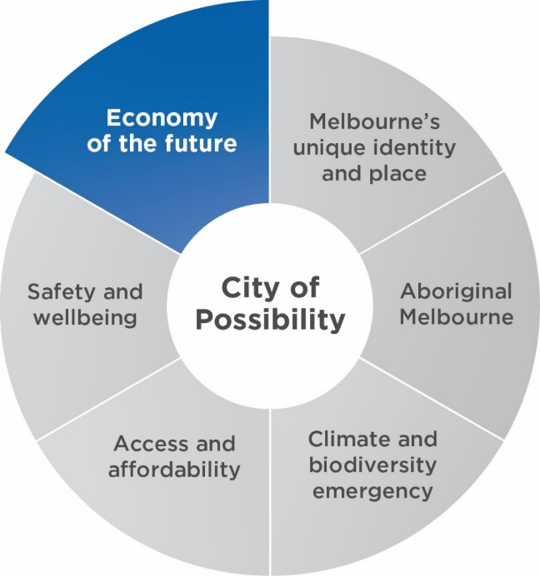

Our priorities
- The city economy is stronger, resilient and fully recovered from the impacts of COVID-19.
- Existing businesses are supported, new businesses, talent and investment are attracted to the city and our growing residential community has access to employment in the municipality.
- Increased economic participation, with a city economy that is more inclusive and fair, enabling residents access to employment and key workers access to accommodation in the city. This priority aligns with, and contributes to, addressing our city's health and wellbeing focus areas.
- Doing business in the city is made more attractive by streamlining processes and alleviating costs.
- The central city is a magnet for events and has a strong reputation as a destination to visit, do business, study and live.
- A financially sustainable and highly effective City of Melbourne organisation.
- Melbourne is a digitally connected city that embraces new industries to create next-generation jobs and businesses.

Major initiatives

Major initiative 1
Continue to strengthen Melbourne’s economic recovery, including through precinct and shopfront activation, delivery of an enhanced business concierge service and support for the night-time economy.

Council’s role
Deliver

Activities for 2022–23 will include
- Continuing to develop the Business Concierge Service as a key point of contact for businesses, and source of support for small to medium sized businesses to establish and grow.
- With guidance from the Night-time Economy Advisory Committee, progressing approved initiatives that support and grow the night-time economy.
- Bringing the strategic plans for each business precinct to life, by creatively activating public space and vacant shops, and incubating creative, entrepreneurial and social enterprises.
- Advocating for and delivering future enhanced city consumer incentive programs.
- Investigating advocacy opportunities to establish a Melbourne free economic zone.

Governance and milestones
- Quarter 2: Council consideration of outcomes of Shopfront Activation Program.
- Quarter 3: Council consideration of a report on a Melbourne free economic zone.
- Quarter 4: Council consideration of a report on delivery of night time economy activation initiatives.
- Quarter 4: Council consideration of Business Precinct Program 2021–25 annual update and decision on funding for year three of the program.

Outcomes
- The City of Melbourne’s retail and hospitality precincts are vibrant and active, with vacancy rate reduced to less than 10 per cent.
- The city continues to reactivate, with pedestrian numbers at 85 per cent of pre-COVID levels and office occupancy rates at 70 per cent of pre-COVID levels.
- City of Melbourne businesses are supported to establish and grow.
- Progress is made towards the 2031 goals in the Economic Development Strategy:
- $150 billion gross local product
- 600,000 jobs.

Related Council Plan indicators of success
- Decrease in vacancy rate of retail premises.
- Increase in number of businesses in the municipality.
- Increase in capital city gross local product.

Related Sustainable Development Goal
Sustainable Development Goal number 8 – Decent Work and Economic Growth

Major initiative 2
Ensure Melbourne is the easiest place to start and grow a business through the establishment of Invest Melbourne which will facilitate headquarter attraction, business support and fast-tracked permits.

Council’s role
Deliver

Activities for 2022–23 will include
- Facilitating and attracting domestic, intra-metropolitan and foreign direct investment.
- Strengthening the city economy so that the city is resilient on track to fully recover from the impacts of COVID-19.
- Supporting existing and new businesses, attracting new talent and investment to Melbourne, and ensuring the growing residential community has access to employment in the municipality.
- Streamlining processes and alleviating costs so that doing business in Melbourne is made more attractive.
- Assisting and facilitating key projects within the municipality and stimulating economic development within major precincts, such as Fishermans Bend, Arden and Parkville.

Governance and milestones:
- Quarter 1: Finalisation of a memorandum of understanding and referral arrangement with the Department of Jobs Precincts and Regions, Investment Division, and Department of Treasury and Finance, Invest Victoria.
- Quarter 2: Council consideration of Invest Melbourne 2022 performance report and update on advisory board.
- Quarter 2: Dashboard reporting in place.
- Quarter 3: Council consideration of Invest Melbourne 2023 half-year performance.
- Quarter 3: Opportunities for streamlined business processes identified.
- Quarter 4: Brand, digital and communications plan delivered.

Outcomes
- Growth in total businesses by 5 per cent, talent attraction to priority sectors (30 per cent of Economic Development Strategy 600,000 jobs target) and attracting investment through Invest Melbourne partnerships.
- Active profiling of Melbourne as a preferred investment destination throughout Australia and South-East Asia.
- Awareness through Invest Melbourne web presence of how easy it is to do business in Melbourne.

Related Council Plan indicators of success
- Increase in number of jobs in the municipality.
- Increase in number of businesses in the municipality.
- Increase In capital city gross local product.

Related Sustainable Development Goal
Sustainable Development Goal number 8 – Decent Work and Economic Growth

Major initiative 3
Drive economic growth and resilience by implementing the Economic Development Strategy, focusing support on existing and emerging industry sectors. This will include close collaboration with industry and universities, development of globally competitive innovation districts (particularly in our renewal areas), strengthening of the creative sector, facilitation of digital and technology innovation, support for re-establishment of international education and efforts to unlock climate capital.

Council’s role
Deliver
Partner

Activities for 2022–23 will include
- Continuing delivery of the Melbourne City Revitalisation Fund.
- Advocating to the Victorian Government and Opposition in advance of the state election for priority projects (for example, redevelopment of Central Pier, public transport to Fishermans Bend) and other initiatives from the City of Melbourne’s Economic Development Strategy.
- Establishing Melbourne as the world’s leading city for student experience by the end of 2023 through the delivery of an ongoing program of international student experiences.
- Supporting establishment and growth of social enterprises through delivery of the Social Enterprise program.
- Increasing the sustainability of the creative sector by exploring increased access to space in the city for creative industries.
- Pursuing opportunities to generate employment in the creative sector.
- Supporting the development of a globally competitive innovation district in City North through development of a Front Door Innovation Hub that connects students, researchers and the entrepreneurial community to innovation facilities, programs and spaces.

Governance and milestones
- Quarter 1: Council consideration of an expanded program of international student experiences.
- Quarter 1: Council consideration of strategic partnership with Victorian Government and stakeholders on Melbourne as the world’s best city for student experience.
- Quarter 2: Student Cities Ranking published.
- Quarter 2: Presentation for councillors’ consideration new activities and initiatives which will generate employment for the creative sector.
- Quarter 2: Creative spaces brokering toolkit developed to test with private sector.
- Quarter 2: Council consideration of Social Enterprise program recipients.
- Quarter 4: Launch of a space to demonstrate proof of concept with private sector and creative industries.

Outcomes
- Progress is made towards 2031 goals in the Economic Development Strategy for Melbourne:
- $150 billion gross local product
- 600,000 jobs.
- The city economy is stronger, resilient and recovering from the impacts of COVID-19, with pedestrian numbers returning towards baseline levels.
- The central city’s strong reputation as a destination to visit, do business, study and live is enhanced through the delivery of international student experiences. This aims to increase their visitation and improve their experience of the city.
- The creative sector is more connected to opportunities for cultural production in Melbourne, with a 20 per cent increase in Creative Spaces website use.
- A number of innovation opportunities are explored in City North through partnerships with the Department of Jobs Precincts and Regions, and other key stakeholders.

Related Council Plan indicators of success
- Increase in number of jobs in the municipality.
- Increase in capital city gross local product.
- Increase in number of visitors to the municipality.
- Value of the creative sector to the local economy.
- The number of creative spaces in the municipality.

Related Sustainable Development Goal
Sustainable Development Goal number 8 – Decent Work and Economic Growth

Major initiative 4
Work in partnership with the Victorian Government and other stakeholders to advocate for and deliver integrated high-quality public and active transport in urban renewal areas including Melbourne Metro 2, tram to Fishermans Bend and tram to connect the Arden precinct.

Council’s role
Partner

Activities for 2022–23 will include
- Advocating to the Victorian and Australian governments for investment in public transport in Melbourne’s urban renewal areas.
- Advocating for the City of Melbourne’s public and active transport objectives, through relevant strategic and statutory planning processes.
- Delivering a shared walking and cycling path on Turner Street in Fishermans Bend, in partnership with Development Victoria as part of the Gateway to GMH project (connecting the former General Motors Holden site with the city and innovation precincts).

Governance and milestones
- Quarter 2: Deliver a targeted advocacy campaign.
- Quarter 4: Resolution of Fishermans Bend tram alignment in the context of planning for the Lorimer Precinct.
- Decisions on development proposals, ensuring provision is made for transport infrastructure requirements (timing dependent on Victorian Government processes).

Outcomes
- Victorian and Australian governments commit to public transport investment in Melbourne’s renewal areas. Victorian Government agency partners support City of Melbourne public transport objectives.
- New and improved active transport options and public realm improvements for Turner Street in Fishermans Bend.

Related Council Plan indicators of success
- Increase in proportion of trips made by public transport, bicycle or on foot.

Related Sustainable Development Goal
Sustainable Development Goal number 9 – Industry, Innovation and Infrastructure
Sustainable Development Goal number 11 – Sustainable Cities and Communities

Major initiative 5
Position Experience Melbourne with industry and government to reinstate Melbourne’s standing as a world class city to live and work in, and visit. This will be achieved through a program of new and refreshed events, marketing and tourism initiatives that ensure Melbourne is a destination of choice.

Council’s role
Deliver
Partner

Activities for 2022–23 will include
- Leveraging established partnerships with other government agencies, industry and peak bodies to maximise collaboration and advocacy on behalf of Melbourne as a world-class city destination.
- Curating Melbourne’s events calendar to maximise visitation and spend, ensuring diversity of event types, spread across calendar year and city locations, and accessibility in terms of price point.
- Targeted marketing campaigns that reinstate Melbourne as the visitor destination of choice.
- New tourism initiatives and a transformed visitor services model, which will grow visitation, and increase visitor engagement and visitor spend.

Governance and milestones
- Quarter 1: New destination marketing campaign implemented.
- Quarter 2: Phase one of visitor services transformation.
- Quarter 4: Phase two of visitor services transformation.
- Quarter 4: Council consideration of campaign outcomes.

Outcomes
- New destination marketing campaign drives growth in visitation and spend, visitor preference for Melbourne.
- Transformation of visitor services to support increased visitor activity and spend, with visitor contacts increasing 10 per cent with 90 per cent visitor satisfaction
- Accommodation occupancy increased to 70 per cent (up from 46 per cent)
- Domestic visitor spend increased to $3 billion (up from $2 billion in 2021)
- Business leads from What’s On increased by 5 per cent to 1 million.

Related Council Plan indicators of success
- Increase in number of visitors to the municipality.

Related Sustainable Development Goal
Sustainable Development Goal number 8 – Decent Work and Economic Growth

Major initiative 6
Market and promote Melbourne as a great place to live for all, while ensuring key workers have access to affordable housing.

Council’s role
Deliver

Activities for 2022–23 will include
- Bringing people back to the city and driving demand for central city-living as the key to strengthening economic resilience in the face of COVID-19, and rebuilding Melbourne’s reputation as liveable, economically prosperous and a desirable place to live, work and invest.
- Extending the Live Melbourne marketing and communications campaign (launched in 2021) for a further year in partnership with key agencies to promote central city-living (subject to funding from the Melbourne City Revitalisation Fund authorised by the Victorian Government).
- Enhancing and supporting the Live Melbourne campaign through a broader destination marketing campaign (see major initiative 5).
- Encouraging the ongoing reduction in stamp duty applicable to CBD apartments by the Victorian government to encourage more people to reside in the city.

Governance and milestones 2022–23
- Quarter 4: Council consideration of campaign outcomes.

Outcomes
- A reduction of 20 per cent in CBD housing stock for sale.
- Evolved Live Melbourne ‘This is your Local’ campaign implemented, generating significant additional views of property online, measured through real estate agency partners.
- Improved sentiment towards the central city as a place to live, increased consideration of the central city as a place to live, and improved sentiment towards visiting Melbourne.
- Visitation levels increased, taking into account COVID-19 constraints.

Related Council Plan indicators of success
- Increase in number of visitors to the municipality.
- Increase in capital city gross local product.
- Increase in number of jobs in the municipality.

Related Sustainable Development Goals
Sustainable Development Goal number 8 – Decent Work and Economic Growth
Sustainable Development Goal number 11 – Sustainable Cities and Communities

Major initiative 7
Increase visitation to Docklands by partnering with the Victorian Government and key stakeholders to enable reconstruction and redevelopment in Central Pier and surrounds.

Council’s role
Partner
Advocate

Activities for 2022-–23 as part of this project will include
- Advocating to Victorian and Australian governments for the redevelopment of Central Pier.
- Partnering with the Victorian Government and key stakeholders to enable demolition of Central Pier and reactivation of the pier and surrounds.
- Pursuing the outcomes of the Docklands Summit, designed to highlight the urgent need for action and inspire enthusiasm for the regeneration of Docklands.
- Supporting increased visitation to Docklands through related initiatives to strengthen economic recovery, tourism and events.

Governance and milestones
- Quarter 2: Opportunities identified to deliver short to medium-term public realm improvements, in partnership with Development Victoria, across the precinct (subject to feasibility and securing budget).
- Quarter 3: Development Victoria secure permit for the demolition of Central Pier (subject to approvals from Heritage Victoria).
- Quarter 3: Input provided on options and design concepts prepared by Development Victoria for the reconstruction of Central Pier.
- Quarter 4: Input provided on Development Victoria’s business case submission to the State budget for 2023, to support the redevelopment of Central Pier and surrounds.
- Quarter 4: Development Victoria supported by City of Melbourne to undertake community and stakeholder engagement on the vision for Central Pier, to inform the business case submission.
- Ongoing: A program of initiatives and events in partnership with Development Victoria that delivers short term activation and drives increased visitation.

Outcomes
- Reactivation of Central Pier precinct.
- Increased visitation to Docklands in response to events and activities.
- Improved economic recovery.

Related Council Plan indicators of success
- Increase in number of visitors to the municipality.
- Decrease in vacancy rate of retail premises.

Related Sustainable Development Goal
Sustainable Development Goal number 8 – Decent Work and Economic Growth

Major initiative 8
Review Melbourne’s international relationships to optimise future and existing partnerships to enable mutual growth and opportunity.

Council’s role
Deliver

Activities for 2022–23 will include
- Delivering and implementing a refreshed International Engagement Strategy. The review will consider which cities to exchange and share knowledge with, and internationally focused actions as outlined in the Economic Development Strategy.
- Continuing to serve and support existing international partnerships, commitments and relationships throughout the review process.
- Leverage diaspora and alumni communities to strengthen international relationships and facilitate foreign investment.

Governance and milestones
- Quarter 2: Council consideration of a new international engagement strategy.

Outcomes
- Enhanced interactions and relationships with targeted international cities and jurisdictions
- International engagement that supports priorities in the Council Plan and key initiatives in the Economic Development Strategy.
- Engagement with agreed cities and jurisdictions delivers key economic, knowledge, cultural and development outcomes for Melbourne and its strategic partner cities.

Related Council Plan indicators of success
- Increase in number of businesses in the municipality.
- Increase in number of visitors to the municipality.

Related Sustainable Development Goal
Sustainable Development Goal number 8 – Decent Work and Economic Growth

Major initiative 9
Partner with industry to support the development of globally competitive innovation ecosystems, including through international engagement, emerging technology trials and digital infrastructure delivery.

Council’s role
Deliver
Partner

Activities for 2022–23 will include
- Working with and supporting technology sectors that have the capacity to be globally competitive, including biotech, medtech, fintech and advanced manufacturing, including through a more focused Business Events Sponsorship Program.
- Providing coordinated support for Melbourne’s innovation, entrepreneurship and startup ecosystem, by partnering with startup ecosystem agencies (including StartupVic and LaunchVic), universities and industry. The aim is to develop programs that will encourage business development and capacity building among more than 2100 startups in Melbourne, and supporting the entrepreneurial efforts of under-represented groups.
- Expanding Melbourne’s global innovation brand and fostering greater knowledge exchange through strengthening connections with Melbourne-based startups with a value of more than $1 billion. This also involves participating in global forums such as Global Entrepreneurship Congress 2023 in Melbourne, profiling Melbourne’s innovation ecosystem through Melbourne Knowledge Week, and creating an innovation alliance network.
- Delivering the Open Innovation Agenda, including Emerging Technology Testbed pilots, the Open Innovation Competition and partnering with industry and government to support innovation events.

Governance and milestones
- Quarter 1: Council consideration of a revised approach to the Business Events Sponsorship Program.
- Quarter 2: Council consideration of a revised approach to the Global Entrepreneurship Congress.
- Quarter 2: Council consideration of funding from the Business Events Sponsorship Program.

Outcomes
- Melbourne’s brand as an innovative global city is enhanced.
- Entrepreneurs, startups and innovation ecosystem players are supported and connected through programs and knowledge-exchange activities.
- Enhanced participation by under-represented groups in innovation programs.
- Emerging technology testbed pilots delivered successfully.
- Significant rollout of 5G infrastructure by telecommunication carriers in the municipality.
- Partnerships created through urban digital infrastructure initiatives.

Related Council Plan indicators of success
- Increase in number of startups in the municipality.
- Increase in number of jobs in the municipality.
- Increase in capital city gross local product.

Related Sustainable Development Goal
Sustainable Development Goal number 8 – Decent Work and Economic Growth

Major initiative 10
Develop a corporate strategy for the City of Melbourne to drive exemplary customer service, digitise services and operations, improve productivity and identify new revenue opportunities.

Council’s role
Deliver

Activities for 2022–23 will include
- Measuring and reporting progress towards the City of Melbourne Corporate Strategy objectives against defined targets and measures to the management team and communicating progress to the organisation.
- Investigating and delivering new streams of revenue.
- Developing a refreshed corporate website.
- Establishing an approach to measure customer experience through City of Melbourne channels, including an agreed governance and measurement framework and identifying opportunities for channel consolidation.

Governance and milestones
- Quarter 2: Consideration of Customer Channel Strategy and Roadmap.

Outcomes
- Progress on key organisational performance metrics is tracked to enable continuous improvement.
- The organisation makes informed decisions.
- City of Melbourne’s corporate website responds to customer and stakeholder needs.
- Agreed governance for customer channels.
- Strategic investment in channel development.
- Maximised benefit from investment in existing technology.

Related Council Plan indicators of success
- Increase in capital city gross local product.
- Number of businesses in the municipality.
- Planning applications decided within required timeframes.

Related Sustainable Development Goal
Sustainable Development Goal number 8 – Decent Work and Economic Growth

Major initiative 11
Embed the Sustainable Development Goals in the way City of Melbourne plans, prioritises its investments, reports and benchmarks against other cities.

Council’s role
Deliver

Activities for 2022–23 will include
- Publishing and presenting Melbourne’s first Voluntary Local Review of progress against the United Nations Sustainable Development Goals at the UN High Level Political Forum on Sustainable Development (a subsidiary body of both the UN General Assembly and the UN Economic and Social Council, responsible for the organisation's policy on sustainable development).
- Convening the inaugural City-to-City Leadership Roundtable.
- Delivering a pilot approach for city-to-city benchmarking, from which future progress can be assessed and comparisons made with other cities to enable increased learning and sharing between cities.
- Identifying at least one shared city partnership and (if feasible) delivering an event for interested partners, stakeholders and investors.
- Ensuring the results of the Voluntary Local Review inform the City of Melbourne’s annual plan and Budget process, and approach to neighbourhood planning.

Governance and milestones
- Quarter 1: Publication of Melbourne’s first Voluntary Local Review.
- Quarter 1: Presentation of Melbourne’s Voluntary Local Review at the UN High Level Political Forum on Sustainable Development.
- Quarter 2: Project update to the Future Melbourne Committee.
- Quarter 4: City-to-City Leadership Roundtable.

Outcomes
- City of Melbourne is recognised as a regional and international leader in sustainable development.
- Sustainable Development Goals are fully integrated into annual plan and budgeting.
- Sustainable Development Goals are integrated into online reporting platform.
- Improvement in key sustainability indicator results.

Related Council Plan indicators of success
- All Council Plan 2021–25 indicators and Sustainable Development Goal targets

Related Sustainable Development Goals
Sustainable Development Goal number 1 – No Poverty
Sustainable Development Goal number 2 – Zero Hunger
Sustainable Development Goal number 3 – Good Health and Well-being
Sustainable Development Goal number 4 – Quality Education
Sustainable Development Goal number 5 – Gender Equality
Sustainable Development Goal number 6 – Clean Water and sanitation
Sustainable Development Goal number 7 – Affordable and Clean Energy
Sustainable Development Goal number 8 – Decent Work and Economic Growth
Sustainable Development Goal number 9 – Industry, Innovation and Infrastructure
Sustainable Development Goal number 10 – Reduced Inequalities
Sustainable Development Goal number 11 – Sustainable Cities and Communities
Sustainable Development Goal number 12 – Responsible Consumption and Production
Sustainable Development Goal number 13 – Climate Action
Sustainable Development Goal number 14 – Life Below Water
Sustainable Development Goal number 15 – Life on Land
Sustainable Development Goal number 16 – Peace, Justice and strong Institutions
Sustainable Development Goal number 17 – Partnership for the goals

Melbourne’s Unique Identity and Place
Over the next four years we will celebrate and protect the places, people and cultures that make Melbourne a unique, vibrant and creative city with world-leading liveability.
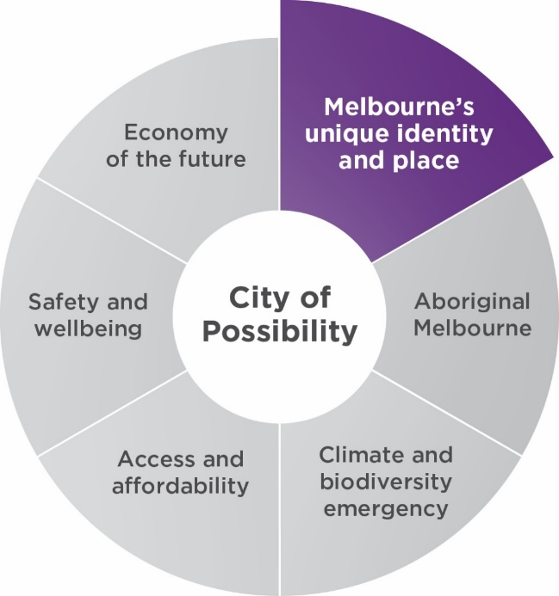

Our priorities
- Our environment, parks and waterways are protected, restored and managed well.
- Our built, natural and cultural heritage is protected.
- New buildings, streets and spaces exhibit design excellence to create sustainable and enduring places and our renewal areas are emerging as high-quality inner-city precincts.
- Melbourne’s diverse communities are celebrated. This major initiative aligns with, and contributes to, addressing our city’s health and wellbeing focus areas.
- Melbourne’s creative, entertainment and education sectors are supported and nurtured.
- Drawing on the full potential of Melbourne’s creative community is central to city planning, design and city operations.
- Melbourne is a university city and aspires to be the number one knowledge city in the world by 2030.

Major initiatives

Major initiative 12
Partner with the Victorian Government and other stakeholders to deliver specific components of Greenline along the north bank of the Yarra River (including the implementation of the Yarra River – Birrarung Strategy).

Council’s role
Deliver
Partner

Activities for 2022–23 will include
- Endorsing a Partnerships and Funding Plan, and business case for the transformation of the north bank along the Yarra River – Birrarung based on the outcomes of ongoing advocacy to the Australian and Victorian governments.
- Conducting an economic impact assessment, quantity surveying and cost planning, and developing a brand strategy for Greenline.
- Collaborating and engaging with Traditional Owners on the Aboriginal heritage elements of the Yarra River – Birrarung towards the goal of Melbourne as an Aboriginal City.
- Partnering with key stakeholders to realise opportunities through delivery of the Greenline Implementation Plan.
- Completing the Greenline Master Plan, precinct plans and concept designs in preparation for commencing stage one of the Birrarung Marr Precinct.

Governance and milestones
- Quarter 1: Council consideration of Partnerships and Funding Plan and business case.
- Quarter 2: Council decision on the contract award for a design services consultancy.
- Quarter 2: Council decision on early works packages (subject to funding and requirements).
- Quarter 3: Endorsement of stage one of the Birrarung Marr Ecological Edge Design.
- Quarter 3: Consideration and decision on the Greenline Master Plan and concept design.
- Quarter 4: Council decision on the contract award for stage one design and construct phase.

Outcomes
- Project funding and in principle partnership agreements in place.
- Active participation by Traditional Custodians and other highly engaged stakeholders.
- Strong community support for the Greenline vision and Master Plan.
- Enhancement of Melbourne’s urban realm and iconic tourism infrastructure.

Related Council Plan indicators of success
- Increase in number of visitors to the municipality.
- Increase in number of jobs in the municipality.

Related Sustainable Development Goals
Sustainable Development Goal number 8 – Decent Work and Economic Growth
Sustainable Development Goal number 11 – Sustainable Cities and Communities

Major initiative 13
Protect Queen Victoria Market as a traditional open-air market, through heritage restoration and the provision of essential services and facilities that enhance the customer and trader experience, including projects such as the Shed Restoration, Food Hall, Trader Shed, Market Square, waste and logistics facility and future developments to the south of the market.

Council’s role
Deliver

Activities for 2022–23 will include
- Completing the Food Hall.
- Commencing construction of the Northern Shed and Trader Shed.
- Completing the Shed Restoration.
- Appointing of a preferred developer for the Southern Development site (south of the Queen Victoria Market car park, adjoining Franklin Street) and progressing development of the Queens Corner Building, subject to Southern Development site outcomes.
- Progressing the Franklin Street roundabout removal, including engagement and release of tender.
- Continuing the design and developing the future use and activities for the new Market Square public open space.

Governance and milestones
- Quarter 2: Council decision on market infrastructure (Trader and Northern Sheds) contract for early works starting early 2023.
- Quarter 2: Council consideration of Franklin Street roundabout concept design.
- Quarter 4: Consideration of Market Square concept design and naming.

Outcomes
- Food Hall delivered on time and on budget by the end of the second quarter enabling Queen Victoria Market to deliver its strategy to achieve increased revenue of approximately $1.8 million and a customer base of 450,000 per year.
- Shed restoration program completed on time and on budget in the fourth quarter delivering more than 15,000 square metres of net lettable area and enabling Queen Victoria Market to attract new traders.
- Stage one of Market Square pop-up delivered with a minimum of 20 arts programs delivered by Testing Grounds, achieving a minimum 10 per cent increase on visitation levels.

Related Council Plan indicators of success
- Increase in number of visitors to the municipality.
- Increase in the number of jobs in the municipality.
- Increase in the proportion of residents within 300 metres of public open space.
- 100 new ‘demonstration’ social and affordable housing units, facilitated on City of Melbourne land.

Related Sustainable Development Goals
Sustainable Development Goal number 7 – Affordable and Clean Energy
Sustainable Development Goal number 8 – Decent Work and Economic Growth
Sustainable Development Goal number 11 – Sustainable Cities and Communities
Sustainable Development Goal number 12 – Responsible Consumption and Production

Major initiative 14
Deliver Queen Victoria Market precinct improvements through quality public open space, new connections to the city, community services and facilities such as the Munro Community Hub.

Council’s role
Deliver
Partner

Activities for 2022–23 will include
- Incorporating Traditional Owner engagement feedback into the detailed design.
- Developing public art space and program.
- Completing the not-for-profit organisation fit-out.
- Completing the Library and Community Hub fit-out.

Governance and milestones
- Quarter 1: Council decision on design and construct tender award.
- Quarter 1: Council consideration of expression of interest for not-for-profit office accommodation.
- Quarter 1: Council decision on appointment of contractor for design and construct phase.
- Quarter 4: Construction completed.

Outcomes
- Core family and library services are accessible to the broadest range of people in the municipality.
- Increased number of active library users.
- More people participate in lifelong learning in the municipality.
- Increased satisfaction with library services.
- Delivery of 300 square metres of Family Services.
- Delivery of 3000 square metres of Library space and services.
- Positive feedback from tenants and local residents.
- Economic reactivation of Queen Victoria Market Precinct.

Related Council Plan indicators of success
- Increase in number of visitors to the municipality.
- 100 new ‘demonstration’ social and affordable housing units facilitated on City of Melbourne land.
- The number of artists supported by City of Melbourne through city planning, design and city operations
- Number of visitors to the municipality.
- Value of the creative sector to the local economy.
- Increased proportion of people surveyed who participate in lifelong learning in the municipality.

Related Sustainable Development Goals
Sustainable Development Goal number 4 – Quality Education
Sustainable Development Goal number 8 – Decent Work and Economic Growth
Sustainable Development Goal number 11 – Sustainable Cities and Communities

Major initiative 15
Deliver public art projects that reflect Melbourne’s unique culture and heritage, attract visitors to the city and help stimulate our city’s recovery.

Council’s role
Deliver

Activities for 2022–23 will include
- Delivering public art projects (both temporary and permanent).
- Pursue funding opportunities to implement a second phase of the Flash Forward Creative Laneways project.

Governance and milestones
- Quarter 1: Hero Building (Russell Street) commission one.
- Quarter 2: Westwood Place Lighting commission.
- Quarter 2: Test Sites Program one.
- Quarter 2: AMCI Partnership commission.
- Quarter 3: Hero Building (Russell Street) commission two.
- Quarter 3: Test Sites Program two.

Outcomes
- Growth in the economic value of Melbourne’s creative sector.
- New partnerships forged to benefit the City of Melbourne, artists and partner organisations.
- Increased economic activity in locations surrounding public art installations.

Related Council Plan indicators of success
- Increase in value of the creative sector to the local economy.
- Increase in number of artists supported by City of Melbourne through city planning, design and city operations.
- Increase in number of visitors to the municipality.

Related Sustainable Development Goals
Sustainable Development Goal number 8 – Decent Work and Economic Growth
Sustainable Development Goal number 11 – Sustainable Cities and Communities

Major initiative 16
Increase the amount of public open space in the municipality with a focus on areas of greatest need, such as Southbank and emerging urban renewal areas.

Council’s role
Deliver

Activities for 2022–23 as part of this project to include
- Acquiring and developing the concept design and community engagement for new open space in Southbank.
- Delivering a pocket park at Bedford Street, North Melbourne, and progressing planning and endorsement of the Chelmsford Street public open space concept plan, including the first round of community engagement.
- Planning for at least two additional pocket parks in areas of need.
- Completing the review of key documents relating to the City of Melbourne Open Space Strategy and prioritising future open space.

Governance and milestones
- Quarter 2: First round of community engagement for new Chelmsford Street open space.
- Quarter 4: Chelmsford Street concept plan endorsement.
- Southbank open space acquisition depending on market conditions.
- Community engagement for Southbank open space, subject to timing of purchase (dependent on market conditions).

Outcomes
- Pocket parks, park expansions and new open space delivered in areas of need, consistent with the Open Space Strategy.

Related Council Plan indicators of success
- 1.1 hectare of new public open space in Southbank.
- Increase in proportion of residents within 300 metres of public open space.

Related Sustainable Development Goal
Sustainable Development Goal number 11 – Sustainable Cities and Communities

Major initiative 17
Play a lead role in facilitating the delivery of high-quality and climate adapted urban renewal in Arden and Macaulay, Fishermans Bend, and Docklands to deliver the emerging and future neighbourhoods of Melbourne in partnership with the Victorian Government and other partners. In Arden and Fishermans Bend, realise the place and investment conditions to support globally competitive innovation districts.

Council’s role
Partner

Activities for 2022–23 will include
- Working with the Victorian Government to implement the Arden Structure Plan and realise early infrastructure and development opportunities.
- Implementing the Macaulay Structure Plan, including the planning scheme amendment.
- Working with the Victorian Government to deliver precinct implementation plans for the Fishermans Bend National Employment and Innovation Cluster and Lorimer precincts.
- Working with the Victorian Government to identify and progress strategic opportunities in Docklands (see major initiative 7).
- Delivering infrastructure strategies and development contribution plans to support successful delivery of the precincts identified.
- Continuing to advocate for increased public housing in Arden.

Governance and milestones
- Quarter 3: Macaulay Planning Scheme Amendment submissions.
- Quarter 4: Council consideration of Fishermans Bend Employment Precinct Implementation Plan.
- Quarter 4: Endorsement of Draft Lorimer Precinct Implementation Plan for consultation.
Note: dates dependent on Victorian Government approval program.
- Macaulay Planning Scheme Amendment exhibited and referred to panel.
- Arden Structure Plan planning controls gazetted.
- Completed consultation on Racecourse Road Strategic Opportunities Plan (with stakeholders).

Outcomes
- Comprehensive urban renewal precinct vision and implementation progressed.

Related Council Plan indicators of success
- Increase in number of jobs in the municipality.
- Increase in proportion of residents employed in the municipality.
- Proportion of residents within 300 metres of public open space.

Related Sustainable Development Goals
Sustainable Development Goal number 6 – Clean Water and sanitation
Sustainable Development Goal number 8 – Decent Work and Economic Growth
Sustainable Development Goal number 11 – Sustainable Cities and Communities
Sustainable Development Goal number 13 – Climate Action

Major initiative 18
Facilitate increased investment in unique Melbourne events to further activate and celebrate the city.

Council’s role
Partner

Activities for 2022–23 will include
- Creating new event support schemes using Melbourne City Revitalisation Fund, and delivering new and expanded City of Melbourne-owned events
- Collaborating with Visit Victoria and Creative Victoria to attract and secure events for Melbourne.
- Providing improved support for event organisers through City of Melbourne’s Events Concierge Service.
- Delivering the Event Partnership Program for 2023, with the program for 2024 opening for applications in May 2023 (subject to the outcome of the review of City of Melbourne-owned and sponsored events undertaken as part of major initiative 5).

Governance and milestones
- Quarter 1: Council consideration of Event Partnership Program 2023 (subject to the outcomes of the Event Review from early 2022, see major initiative 5).
- Quarter 4: Event Partnership Program 2024 opens.

Outcomes
- Melbourne is reaffirmed as Australia’s premier visitor destination, as the ‘events capital of Australia’, and as a destination of choice for event organisers and film production companies.

Related Council Plan indicators of success
- Increase in number of visitors to the municipality.
Sustainable Development Goal number 8 – Decent Work and Economic Growth

Major initiative 19
Celebrate, partner and advocate for investment in the city’s three key waterways, the Yarra River – Birrarung, the Maribyrnong and Moonee Ponds Creek, to connect these key recreational and biodiversity assets of our city.

Council’s role
Partner
Advocate

Activities for 2022–23 will include
- Advocating for implementation of the Moonee Ponds Creek Strategic Opportunities Plan, including exploration of creek improvements in the southern reaches and reinstatement of the Docklands section of the Moonee Ponds Creek Trail.
- Advocating for the coordinated governance of Melbourne’s key waterways by the Victorian Government, including resolving fragmented land ownership and responsibilities across government agencies and departments.
- Advocating and supporting delivery of the Greenline project (particularly in Docklands), which will deliver significant aspects of the Yarra River – Birrarung Strategy, including the redevelopment of the north bank of the river.

Governance and milestones
- Quarter 1: Development Contribution Plan in place for Arden.
- Quarter 4: Development Contribution Plan in place for Macaulay.

Outcomes
- Income generated by Arden and Macaulay development contribution plans provide for meaningful improvements around Moonee Ponds Creek.
- Partnership funding and delivery of projects within Melbourne’s three key waterways.

Related Council Plan indicators of success
- Increase in number of visitors to the municipality.
- Increase in proportion of residents within 300 metres of public open space.

Related Sustainable Development Goals
Sustainable Development Goal number 6 – Clean Water and sanitation
Sustainable Development Goal number 8 – Decent Work and Economic Growth
Sustainable Development Goal number 11 – Sustainable Cities and Communities
Sustainable Development Goal number 14 – Life Below Water
Sustainable Development Goal number 15 – Life on Land

Major initiative 20
Adopt the Municipal Planning Strategy in 2022–23

Council’s role
Deliver

Activities for 2022–23 will include
- Producing a new Municipal Planning Strategy – a critical part of the Melbourne Planning Scheme which provides an overview of local planning issues and sets the vision and strategic direction for future land use and development in the municipality.
- Finalising the City Spatial Plan, a place-based vision for change and growth across the municipality which identifies how local places can adapt and respond to change over the next two decades, and is a strategic basis for the Municipal Planning Strategy.

Governance and milestones
- Quarter 2 and 3: Exhibition of draft City Spatial Plan and Municipal Planning Strategy.
- Quarter 2: Council consideration of submissions.
- Quarter 4: Endorsement of the City Spatial Plan.
- Quarter 4: Endorsement of the Municipal Planning Strategy.
- Completion of engagement including panel process.
Note: dates subject to Victorian Government approval processes.

Outcomes
- A new and updated Municipal Planning Strategy is formally included in the Melbourne Planning Scheme in 2022–23.
- The Municipal Planning Strategy delivers better planning outcomes which reflect Council’s current strategies.
- Interface and relationship with the neighbourhood plans mature over time.

Related Council Plan indicators of success
- All Council Plan 2021–25 indicators and Sustainable Development Goal targets

Related Sustainable Development Goals
Sustainable Development Goal number 1 – No Poverty
Sustainable Development Goal number 2 – Zero Hunger
Sustainable Development Goal number 3 – Good Health and Well-being
Sustainable Development Goal number 4 – Quality Education
Sustainable Development Goal number 5 – Gender Equality
Sustainable Development Goal number 6 – Clean Water and sanitation
Sustainable Development Goal number 7 – Affordable and Clean Energy
Sustainable Development Goal number 8 – Decent Work and Economic Growth
Sustainable Development Goal number 9 – Industry, Innovation and Infrastructure
Sustainable Development Goal number 10 – Reduced Inequalities
Sustainable Development Goal number 11 – Sustainable Cities and Communities
Sustainable Development Goal number 12 – Responsible Consumption and Production
Sustainable Development Goal number 13 – Climate Action
Sustainable Development Goal number 14 – Life Below Water
Sustainable Development Goal number 15 – Life on Land
Sustainable Development Goal number 16 – Peace, Justice and strong Institutions
Sustainable Development Goal number 17 – Partnership for the goals

Major initiative 21
Complete heritage reviews and implement associated planning scheme amendments to protect and celebrate heritage in our municipality.

Council’s role
Deliver

Activities for 2022–23 will include
- Commencing the East Melbourne / Jolimont heritage review.
- Finalising the Parkville heritage review and beginning the planning scheme amendment.
- Progressing the planning scheme amendments for Carlton (to adoption), South Yarra (to exhibition) and North Melbourne (to planning panel).
- Continuing to support and contribute to the Melbourne Heritage Restoration Fund.
- Completing the heritage data project and database with public interface.

Governance and milestones
- Quarter 1: Authorisation of South Yarra planning scheme amendment.
- Quarter 1: Council consideration of Carlton planning scheme amendment submissions.
- Quarter 2: Council consideration of North Melbourne planning scheme amendment submissions.
- Quarter 3: Authorisation of Parkville heritage planning scheme amendment.
- Quarter 3: Council consideration of South Yarra planning scheme amendment submissions.
- Quarter 4: Council consideration of Carlton planning scheme amendment.

Outcomes
- Neighbourhoods in the municipality have up-to-date local heritage studies and controls.
- Up-to-date and contemporary regulations, and supporting studies, ensure the preservation of neighbourhood heritage character and facilitate appropriate, high-quality future development.
- City of Melbourne leads by example through public investment in heritage building restorations.
- The public has access to detailed heritage data.

Related Council Plan indicators of success
- All neighbourhoods in the municipality have up-to-date local heritage studies and controls.

Related Sustainable Development Goal
Sustainable Development Goal number 11 – Sustainable Cities and Communities

Major initiative 22
Champion high quality development and public realm design through delivering the Design Excellence Program, including implementing the City of Melbourne Design Review Panel and a Design Excellence Committee for strategic planning work.

Council’s role
Deliver

Activities for 2022–23 will include
- Coordinating the Melbourne Design Review Panel and Design Excellence Advisory Committee sub-programs (providing a platform for industry, academia and community to engage on municipal design topics and advise Council on the delivery of its Design Excellence Program).
- Undertaking stakeholder consultation on draft design competition guidelines.
- Transitioning the existing 12-month pilot Melbourne Design Review Panel into a permanent, highly valued and effective ongoing program.

Governance and milestones
- Quarter 2: Council consideration of draft Design Competition Guidelines and Design Excellence Advisory Committee 12-month recommendations.
- Quarter 3: Council consideration of Melbourne Design Review Panel 12-month pilot outcomes and recommendations.
- Ongoing quarterly Design Excellence Advisory Committee meetings.
- Ongoing bi-monthly Melbourne Design Review Panel meetings, covering planning applications and Council projects.

Outcomes
- Positive customer experience and community sentiment survey results.
- Increased number of design awards for buildings and public spaces in the municipality.
- Design Excellence Advisory Committee recommendations shared with Councillors.
- Melbourne Design Review Panel 12-month pilot recommendations endorsed.
- Greater visibility and awareness of City of Melbourne design ambitions and expertise.

Related Council Plan indicators of success
- Increase in the number of design reviews of major projects.

Related Sustainable Development Goal
Sustainable Development Goal number 3 – Good Health and Well-being
Sustainable Development Goal number 9 – Industry, Innovation and Infrastructure
Sustainable Development Goal number 11 – Sustainable Cities and Communities
Sustainable Development Goal number 15 – Life on Land

Aboriginal Melbourne
For the Wurundjeri, Bunurong, Taungurung, Dja Dja Wurrung and Wadawurrung peoples of the Eastern Kulin, the place now known as Melbourne has always been an important meeting place and location for events of political, cultural, social and educational significance. Over the four years of the Council Plan 2021–25, we will ensure that First Peoples’ culture, lore, knowledge, and heritage enrich the city’s growth and development.
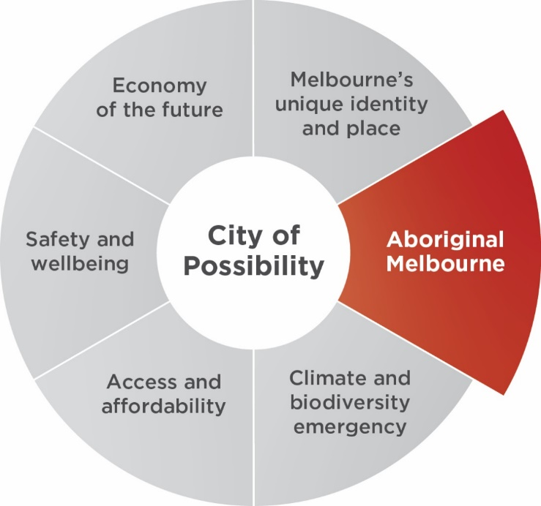

Our priorities
- Governing with First Peoples drives our city forward and allows community to make the changes needed for the City of Melbourne to be an Aboriginal city. This priority aligns with, and contributes to, addressing our city's health and wellbeing focus areas.
- We embrace and promote our First Peoples’ identity across all areas of the city, including city design, and give voice to the treaty process with First Peoples. This priority aligns with, and contributes to, addressing our city's health and wellbeing focus areas.
- The community is well educated about Melbourne’s First Peoples’ culture, lore, knowledge and heritage.
- The activation and protection of First Peoples’ culture and know-how is a key driver to economic growth and increases Melbourne’s international engagement and participation.
- First Peoples experts are consulted and lead sustainable land management practices and implement ‘Caring for Country’ principles in the management, planning and development of city land. This priority aligns with, and contributes to, addressing our city's health and wellbeing focus areas.

Major initiatives

Major initiative 23
Explore and deliver opportunities for ‘truth-telling’ to facilitate learning, healing, and change within Melbourne and beyond. This will be an opportunity to impart knowledge of thousands of years of rich history, language and stories, as well as provide a form of restorative justice by acknowledging Aboriginal peoples’ experiences of dispossession and inequity.

Council’s role
Partner

Activities for 2022–23 will include
- Establishing a Stolen Generations memorial site to recognise the Aboriginal and Torres Strait Islander children forcibly removed from their families and communities between 1910 and the 1970s.
- Delivering activities and events for Sorry Day in May 2023.
- Launching the Seasons Project in May 2023 to inform and educate people about the seven Wurundjeri seasons to better understand the Country they live on.
- Delivering a series of activities and events for National Reconciliation Week in May and June 2023.
- Advocacy by the Lord Mayor, councillors and staff for truth telling at important functions and occasions.

Governance and milestones
- Quarter 3: Council consideration and decision on Stolen Generations Memorial Site.
- Quarter 4: National Reconciliation Week Oration and program delivered.

Outcomes
- Thousands of years of rich history, language and stories will be shared. A form of restorative justice will be provided by acknowledging Aboriginal peoples’ experiences of dispossession and inequity.

Related Council Plan indicators of success
- 100 per cent of people surveyed believe the relationship with Aboriginal people is important.
- 100 per cent of people surveyed demonstrate an understanding of Melbourne’s Aboriginal heritage and culture.

Related Sustainable Development Goals
Sustainable Development Goal number 10 – Reduced Inequalities
Sustainable Development Goal number 11 – Sustainable Cities and Communities

Major initiative 24
Implement the Declaration of Recognition and Commitment in good faith which signals and elevates the City of Melbourne’s shared commitment for reconciliation across the whole of the organisation.

Council’s role
Deliver

Status
This initiative has been completed.

Major initiative 25
Govern with Sovereign First Nations to enable true self-determination, where deliberative engagement is proactive, responsive and consistent.

Council’s role
Deliver

Activities for 2022–23 will include
- Consulting with Aboriginal people to define what is meant by governing with Sovereign First Nations to inform the design of a governance framework.
- Separately, developing an agreed protocol or memorandum of understanding between the City of Melbourne and Registered Aboriginal Parties to improve decision-making processes impacting on land and heritage, and Aboriginal participation in public parks and place management.

Governance and milestones
- Quarter 2: Council consideration of issues around governing with Sovereign First Nations people and groups.

Outcomes
- Traditional Owners have a genuine voice as members of the municipality.
- A framework to enable and strengthen self-determination and build strong and respectful relationships with Traditional Owner groups.

Related Council Plan indicators of success
- Increase in involvement of Traditional Owners in city governance.

Related Sustainable Development Goals
Sustainable Development Goal number 10 – Reduced Inequalities
Sustainable Development Goal number 11 – Sustainable Cities and Communities
Sustainable Development Goal number 16 – Peace, Justice and strong Institutions

Major initiative 26
Commence planning for a co-designed First Nations Cultural Precinct with First Peoples – a place to retain, maintain and recreate in a culturally specific geography, where First Peoples can practice continuity of customs and traditions, through uninterrupted connection to lands and waters.

Council’s role
Partner

Activities for 2022–23 will include
- Continuing delivery of the First Nations Cultural Precinct in partnership with Victorian and Australian governments.
- Continuing engagement with Traditional Owners, and Aboriginal community regarding the governance structure and First Nations Cultural Precinct.

Governance and milestones
- Quarter 1: Review of Victorian and Australian government Budget outcomes

Outcomes
- An Aboriginal-owned, led and operated, and financially sustainable First Nations Cultural Precinct.
- An investment which delivers strong economic and social benefits for Melbourne.

Related Council Plan indicators of success
- Increase in involvement of Traditional Owners in city governance.
- 100 per cent of people surveyed demonstrate an understanding of Melbourne’s Aboriginal heritage and culture.
Sustainable Development Goal number 10 – Reduced Inequalities
Sustainable Development Goal number 11 – Sustainable Cities and Communities
Sustainable Development Goal number 16 – Peace, Justice and strong Institutions

Major initiative 27
Support a partnership forum – an annual gathering of the Eastern Kulin (noting the history of Tanderrum).

Council’s role
Partner

Activities for 2022–23 will include
- Engaging with representatives of the Aboriginal community in Melbourne and Victoria to support discussion of an annual gathering of the Eastern Kulin.

Governance and milestones
- Quarter 2: Development of a draft governance framework.

Outcomes
- A governance framework for building a stronger relationship with Traditional Owner groups based on mutual respect and shared understanding of Melbourne’s history.
- Provision of local views to the National Voice where this informs national issues.

Related Council Plan indicators of success
- 100 per cent of people surveyed demonstrate an understanding of Melbourne’s Aboriginal heritage and culture.

Related Sustainable Development Goals
Sustainable Development Goal number 10 – Reduced Inequalities
Sustainable Development Goal number 11 – Sustainable Cities and Communities

Climate and Biodiversity Emergency
Over the next four years, we will prioritise our environment and take urgent action to reduce emissions and waste in order to protect public health, strengthen the economy and create a city that mitigates and adapts to climate change. The City of Melbourne declared a climate and biodiversity emergency in 2019.
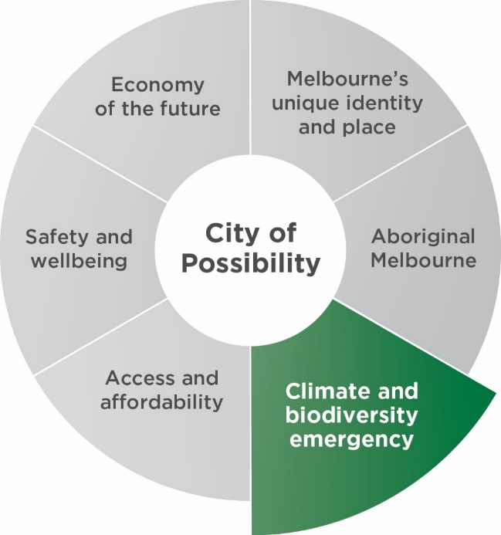

Our priorities
- City of Melbourne is a global leading city that sets the standard in climate action. This priority aligns with, and contributes to, addressing our city's health and wellbeing focus areas. Lead the transition towards zero net emissions for the city.
- Eliminate waste through circular economies.
- Spaces and buildings showcase world-leading sustainable design principles to enhance liveability and lead innovative responses to climate change, including protecting communities from the impact of extreme weather events. This priority aligns with, and contributes to, addressing our city's health and wellbeing focus areas.
- Resilient and safe communities that are adapting to the public health impacts of climate change. This priority aligns with, and contributes to, addressing our city's health and wellbeing focus areas.
- Biodiversity, habitat, green spaces, water quality and tree canopy cover are increased in the city. This priority aligns with, and contributes to, addressing our city's health and wellbeing focus areas.

Major initiatives

Major initiative 28
To enhance Melbourne’s position as a global leader on climate action, we will undertake bold advocacy on behalf of our community.

Council’s role
Advocate

Activities for 2022–23 will include
- Engaging with the Victorian and Australian governments.
- Establishing a way to build organisational capacity to partner with the community on advocating for climate action.
- Lord Mayor, councillors and CEO, and executive engagement in key national and global events when appropriate.

Governance and milestones
- Quarter 2: COP27 (UN Climate Change Conference of Parties) national interim targets and action plans developed.
- Quarter 3: Victorian Government interim targets released.

Outcomes
- The Victorian and Australian governments commit to aligned 1.5°C emissions reduction and renewable energy targets.
- The Victorian Government progresses on​ zero net emissions, climate-adapted buildings and precincts by 2030.
- The Australian Government progresses with its rollout of the Australian Energy Market Operator, Integrated System Plan step change scenario and national emissions standards for vehicles. And commits to the 2030 realisation of zero net emissions and climate-adapted building regulation in the National Construction Code.

Related Council Plan indicators of success
- 33 per cent reduction in municipal greenhouse gas emissions (from 2015 baseline).

Related Sustainable Development Goal
Sustainable Development Goal number 13 – Climate Action

Major initiative 29
Create an enabling environment for Melbourne businesses and universities to become the employment centre of a resilient zero-carbon economy.

Council’s role
Partner

Activities for 2022–23 will include
- Conducting a market opportunities assessment to examine the current state and future opportunities for growth of a zero-carbon economy in Melbourne that supports employment.
- Conducting the inaugural Zero Carbon: Maximum Jobs Summit, bringing together business, community and academic leaders to develop an agreed way forward.
- Establishing a Zero-Carbon Jobs Cluster that will prioritise the creation of local knowledge-economy jobs in the clean energy, climate adaptation and related fields, and support innovation through universities, small businesses and startups that deliver positive social and environmental benefits.

Governance and milestones
- Quarter 3: Council consideration of recommendations including City of Melbourne value proposition for green jobs and zero-carbon jobs targets for 2024–25 and 2025–26

Outcomes
- Melbourne is positioned as a global centre for the zero-carbon economy.

Related Council Plan indicators of success
- 33 per cent reduction in municipal greenhouse gas emissions (from 2015 baseline).
- Increase in number of startups in the municipality.
- Increase in number of jobs in the municipality.

Related Sustainable Development Goals
Sustainable Development Goal number 8 – Decent Work and Economic Growth
Sustainable Development Goal number 13 – Climate Action

Major initiative 30
Progress a planning scheme amendment to improve the environmental performance of buildings, in order to reduce emissions to zero by 2040.

Council’s role
Deliver

Activities for 2022–23 will include
- Negotiating with the Victorian Government to progress and implement the planning scheme amendment.
- Depending on the outcome of this planning scheme amendment, pursuing alternative options to improve the environmental performance of new buildings (see major initiative 35).
- Investigate options to promote or regulate disclosure of embodied carbon in new buildings.

Governance and milestones
- Planning scheme amendment authorised by the Minister for Planning.

Outcomes
- High level of community engagement in sustainable building design standards.
- Melbourne remains on track to achieve the target of net-zero emissions by 2040, by increasing green cover, and reducing water use, electricity consumption and the amount of waste to landfill.

Related Council Plan indicators of success
- 33 per cent reduction in municipal greenhouse gas emissions (from 2015 baseline).

Related Sustainable Development Goal
Sustainable Development Goal number 13 – Climate Action

Major initiative 31
Deliver on our Urban Forest Strategy including tree canopy, private greening incentives and city greening.

Council’s role
Deliver

Activities for 2022–23 will include
- Continuing the Tree Planting Program
- Implementing the Urban Forest precinct plans to achieve a healthy, resilient and diverse urban forest for the municipality.
- Delivering round four grants through the Urban Forest Fund to support local greening projects.
- Delivering the Canopy Uplift Program.
- Continuing to deliver the Citizen Forester Program to encourage citizens to help create a greener Melbourne.
- Implementing the Tree Policy to protect trees.
- Beginning to renew the Urban Forest Precinct Plans for the next decade.

Governance and milestones
- Quarter 1, 4: Tree canopy data collected
- Quarter 2: Council consideration of progress on Urban Forest Strategy.
- Quarter 4: Tree canopy data collected

Outcomes
- Tree Planting Program is on track to increase canopy cover to 40 per cent by 2040.
- Community participation in workshops and engagement events.
- Increased tree species diversity and improved vegetation health, soil quality and urban ecology.

Related Council Plan indicators of success
- 27 per cent tree canopy cover in the public realm.
- 2400 trees planted, plus the number removed in the previous year, or 3000 trees planted in the municipality (whichever is greater).

Related Sustainable Development Goal
Sustainable Development Goal number 15 – Life on Land

Major initiative 32
Lead the reduction of food waste and diversion of waste from landfill, by continuing the food organics, green organics rollout through high-rise apartment innovation and by addressing food-waste reduction.

Council’s role
Deliver

Activities for 2022–23 will include
- Reviewing the outcomes of the food and green organics recycling program in low-rise buildings.
- Reviewing the outcomes of the first food and green organics recycling pilot in high-rise buildings.
- Reviewing options for additional organics recycling services.

Governance and milestones
- Quarter 3: Council consideration of future pilot options for high-rise buildings.

Outcomes
- 50 per cent of food waste from participating households diverted from landfill.
- Five storey high-rise residential buildings have access to the organics recycling service.
- Maintain 50 per cent rate for diversion of food waste from landfill, based on participating households.

Related Council Plan indicators of success
- 50 per cent increase in municipal waste diverted from landfill.

Related Sustainable Development Goal
Sustainable Development Goal number 12 – Responsible Consumption and Production

Major initiative 33
Support the development of a circular economy through bold leadership and community neighbourhood projects, including the container deposit scheme, alternative waste technologies, circular economy guidelines and partnered or aggregated demand to stimulate end markets.

Council’s role
Partner

Activities for 2022–23 will include
- Reviewing suitable glass collection service options that maximise circular economy outcomes and meet the Recycling Victoria policy requirements, taking into consideration the findings of the container deposit scheme review and collaborative options with the ‘M9’ (inner Melbourne) local councils.
- Implementing and delivering the Circular Economy Guidelines, focusing on education and embedding circular outcomes within the community and CBD businesses.
- Running the pilot Circular Economy Business Precinct Program, showcasing circular economy practices and assisting businesses to minimise waste.
- Reviewing opportunities available to the City of Melbourne for advanced waste technologies that can process our residual waste, and maximise landfill diversion.
- Developing collaborative partnerships and opportunities with neighbouring councils (though the M9 inner Melbourne local council network), aimed at driving innovation within the recycling market and circular economy outcomes.

Governance and milestones
- Quarter 1: Council consideration of Circular Economy Guidelines.
- Quarter 2: Launch of Circular Economy Business Precinct Program.
- Completed review of the municipal waste charge to maintain equity and facilitate waste reduction aligned with the Waste and Resource Recovery Strategy 2030.

Outcomes
- New Circular Economy Guidelines support better use and investment in new recycled materials for construction, and better decommissioning of buildings towards the end of operation.
- Increased awareness and application of circular economy practices and principles by the community and City of Melbourne.

Related Council Plan indicators of success
- 50 per cent increase in municipal waste diverted from landfill.

Related Sustainable Development Goal
Sustainable Development Goal number 12 – Responsible Consumption and Production

Major initiative 34
Support the development of battery storage and renewable energy in the municipality through the Power Melbourne initiative.

Council’s role
Partner

Activities for 2022–23 will include
- Developing a business case to establish a network of batteries in the municipality and partnership with an electricity retailer.
- Running a tender process to engage a battery and retail partner (subject to Council approval of the business case).
- Developing a memorandum of understanding with other councils to partner on retail renewable electricity offerings for residents and small business.
- Piloting battery installation on a City of Melbourne asset and completing the design for rollout across several sites.
- Developing a plan and agreement to integrate assets from RMIT and University of Melbourne into the battery network.
- Delivering community engagement activities to support battery deployment (pending Victorian Government grant funding).
- Pursuing external funding to support capital works.

Governance and milestones
- Quarter 1: Commencement of community engagement activities.
- Quarter 3: Council appointment of commercial delivery partner.

Outcomes
- Increased battery storage capacity in the municipality.
- Installation of at least 100 kilowatts of battery storage capacity in the municipality with the ability to scale up to 5 megawatts in 2023 to 2025.
- Community support for participation in Power Melbourne and viable battery locations.

Related Council Plan indicators of success
- Increase in installed battery storage capacity in the municipality.

Related Sustainable Development Goal
Sustainable Development Goal number 7 – Affordable and Clean Energy

Major initiative 35
Implement the Climate and Biodiversity Emergency action plan.

Council’s role
Deliver

Activities for 2022–23 will include
- Delivering priority actions from the Climate and Biodiversity Emergency Response.
- Continuing to implement the gas-free operations roadmap to reduce City of Melbourne’s fossil fuel use.
- Updating City of Melbourne policies and processes to ensure climate change and biodiversity opportunities and risks are considered throughout the lifecycle for all City of Melbourne owned assets.
- Accelerating the adoption of zero net emissions vehicles in the City of Melbourne’s vehicle fleet, influencing key suppliers through contracts and assessing opportunities for electric vehicle charging within the municipality.
- Progressing existing initiatives including expanding urban tree canopy cover, rapid city greening, direct seeding and integrating the Green Factor infrastructure assessment tool into planning requirements to improve environmental performance and incorporate green infrastructure in new buildings.
- Supporting the development of a circular economy (see major initiative 33).
- Developing additional options (to a rates mechanism) to incentivise good environmental performance in existing buildings.

Governance and milestones
- Quarter 2: Council consideration of progress on Climate and Biodiversity Emergency action plan.

Outcomes
- Major City of Melbourne events achieve carbon neutrality, and this achievement is communicated to the community and other event organisers.
- City of Melbourne is on track to achieve gas-free operations.

Related Council Plan indicators of success
- 33 per cent reduction in municipal greenhouse gas emissions (from 2015 baseline).
- Decrease in on-road transport emissions.

Related Sustainable Development Goals
Sustainable Development Goal number 13 – Climate Action
Sustainable Development Goal number 15 – Life on Land

Access and Affordability
Over the next four years, we will reduce economic and social inequality by ensuring universal access to housing, core services and information.
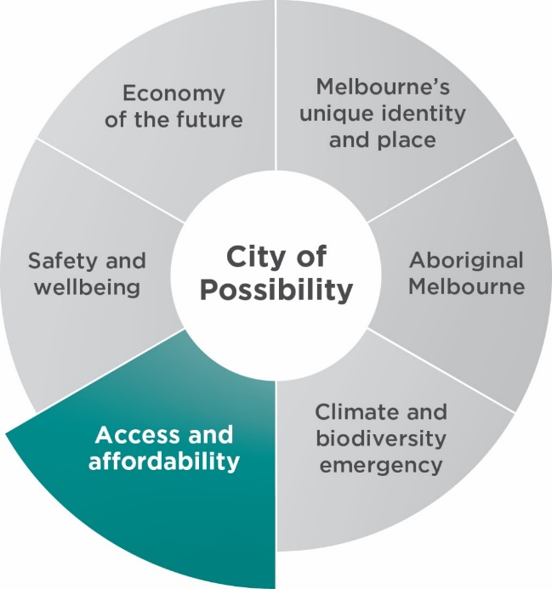

Our priorities
- Fair, appropriate and accessible range of affordable housing for people of all backgrounds is available, with special focus on people experiencing homelessness. This priority aligns with, and contributes to, addressing our city's health and wellbeing focus areas.
- Increased food security for everyone, especially the most vulnerable. This priority aligns with, and contributes to, addressing our city's health and wellbeing focus areas.
- Core services are accessible and affordable to everyone, with special attention to mental health, lifelong education and internet services. This priority aligns with, and contributes to, addressing our city's health and wellbeing focus areas.
- City activities including events, the arts and culture are accessible and affordable for everyone. This priority aligns with, and contributes to, addressing our city's health and wellbeing focus areas.
- People with disability feel welcome in the city and have equal access. This priority aligns with, and contributes to, addressing our city's health and wellbeing focus areas.

Major initiatives

Major initiative 36
Increase and upgrade accessible, inclusive spaces for women in City of Melbourne sports facilities.

Council’s role
Deliver

Activities for 2022–23 will include
- Completing construction of the new Brens Pavilion to improve accessibility for women and girls.
- Commencing construction of Ryder Pavilion to improve accessibility for women and girls.
- Commencing construction of Kensington Community Aquatic and Recreation Centre.
- Completing the detailed design for the redevelopment of Riverslide Skate Park
- Completing the detailed design for reinstating Edmund Herring Oval in Domain Parklands following Metro Tunnel works. Anticipated in 2024, including for the pavilion upgrade, sports ground lighting and playing surface (subject to budget).
- Determining the next priority for sporting infrastructure redevelopment to progressively upgrade sporting facilities to ensure they are accessible, inclusive, safe and fit for purpose for all sporting participants, with a specific focus on gender equity.

Governance and milestones
- Quarter 2: Council decision on construction contract for Ryder Pavilion (subject to budget).
- Quarter 4: Council consideration of Edmund Herring Ground precinct design (subject to budget).

Outcomes
- The City of Melbourne’s recreation infrastructure upgrades meet all gender access requirements.

Related Council Plan indicators of success
- Increase in proportion of adults who get adequate physical exercise.
- Melburnians’ self-reported sense of belonging to community is at least 70 on a scale of 100.

Related Sustainable Development Goals
Sustainable Development Goal number 3 – Good Health and Well-being
Sustainable Development Goal number 5 – Gender Equality
Sustainable Development Goal number 10 – Reduced Inequalities
Sustainable Development Goal number 11 – Sustainable Cities and Communities

Major initiative 37
Implement a neighbourhood model by working with communities to develop neighbourhood plans and neighbourhood service centres that respond to the local community’s existing and projected needs.

Council’s role
Deliver

Activities for 2022–23 will include
- Working with communities to build a vision for their local area, and developing 11 neighbourhood plans.
- Expanding the neighbourhood knowledge bank to allow general City of Melbourne staff to collect knowledge and insights about our local neighbourhoods, and making the information available to the community.
- Establishing a neighbourhood stakeholder management system administering a City of Melbourne grant program to focus on neighbourhood priorities, enhancing the volunteering program to meet neighbourhood needs, undertaking planning to deliver social and inclusive employment outcomes through City of Melbourne’s procurement practices.
- Undertaking an inclusive spaces pilot at the North Melbourne Community Centre as part of the Active Melbourne Recreation Facilities model.

Governance and milestones
- Quarter 2: Council consideration of final neighbourhood plans.

Outcomes
- Increased number of community led initiatives in neighbourhoods
- Increased positive connections between City of Melbourne and community.

Related Council Plan indicators of success
- Melburnians’ self-reported sense of belonging to community is at least 70 on a scale of 100.

Related Sustainable Development Goals
Sustainable Development Goal number 10 – Reduced Inequalities
Sustainable Development Goal number 11 – Sustainable Cities and Communities
Sustainable Development Goal number 16 – Peace, Justice and strong Institutions

Major initiative 38
Deliver a revitalised library network, including pop-up libraries, to increase access for our diverse community and to help revitalise the city.

Council’s role
Deliver

Activities for 2022–23 will include
- Delivering pop-up libraries in up to five fixed locations.
- Implementing actions from the Future Libraries Framework 2021–25, including better ways to represent and celebrate Aboriginal culture, connecting new audiences with our libraries, targeted support for vulnerable people, developing new and imaginative ways to deliver accessible 24-hour library services.
- Developing an operational model for library services in the new Munro Library including engagement outcomes.
- Developing a plan for the future City Library in Flinders Lane.

Governance and milestones
- Quarter 4: Council consideration of recommendations for future City Library in Flinders Lane.

Outcomes
- Precincts are activated where libraries are located.
- The number of active library users increases.
- Satisfaction with library services increases.
- More people participate in lifelong learning in the municipality.

Related Council Plan indicators of success
- Increase in proportion of people surveyed who participate in lifelong learning in the municipality.
- Increase in number of visitors to the municipality.

Related Sustainable Development Goals
Sustainable Development Goal number 4 – Quality Education
Sustainable Development Goal number 8 – Decent Work and Economic Growth
Sustainable Development Goal number 10 – Reduced Inequalities

Major initiative 39
Deliver the Disability Access and Inclusion Plan 2020–24 including ensuring our services and events are more accessible, increasing the number of accessible adult change facilities, and partnering with community and transport groups to make transport more accessible.

Council’s role
Deliver
Partner

Activities for 2022–23 will include
- Implementing the third year of the Disability Access and Inclusion Plan including. Actively engaging people with a disability in city-shaping initiatives including Greenline, Transport Strategy, Visit Melbourne and other major initiatives. Increasing the number of changing places facilities, completing building access audits in our building design and delivery. It also includes hosting an event to acknowledge 30 years of the Disability Discrimination Act, development of disability access keys for events – to provide support for people with cognitive and psychosocial disabilities, and the rolling out of disability awareness training.
- Delivering a companion pilot project by Travellers Aid at events including Moomba and the Melbourne Flower and Garden Show to support people with a disability to navigate these events.

Governance and milestones
- Quarter 3: Council consideration of progress on delivery of Disability Access and Inclusion Plan.

Outcomes
- City of Melbourne projects, programs and services are more focused on inclusion.
- There is increased City of Melbourne engagement with the Disability Advisory Committee and people experiencing disabilities.

Related Council Plan indicators of success
- Increase in number of City of Melbourne programs that are inclusive and respond to the needs of people with disability.
- Melburnians’ self-reported sense of belonging to community is at least 70 on a scale of 100.

Related Sustainable Development Goals
Sustainable Development Goal number 9 – Industry, Innovation and Infrastructure
Sustainable Development Goal number 10 – Reduced Inequalities
Sustainable Development Goal number 11 – Sustainable Cities and Communities

Major initiative 40
Develop and deliver initiatives and programs that will provide food relief to vulnerable members of our community and improve local food production by supporting communities to grow their own food.

Council’s role
Deliver
Partner
Advocate

Activities for 2022–23 will include
- Working with food relief providers to improve coordination of local food relief across the municipality, including food donation processes.
- Implementing community food literacy initiatives (for example, food growing and meal preparation on a low budget).
- Identifying and understanding innovative approaches to food growing in urban settings.
- Reviewing and refreshing the City of Melbourne's Food Policy.
- Distributing and promoting the updated Community Food Guide to food relief providers and community support services within Melbourne’s neighbourhoods.

Governance and milestones
- Quarter 1: Promotion of the Community Food Guide, and its distribution to food relief providers.
- Quarter 4: Council Consideration of updated City of Melbourne Food Policy.

Outcomes
- Improved relationships with local food relief providers.
- Increased community knowledge on food growing and meal preparation on low budget.
- Improved knowledge and understanding of urban food growing opportunities.
- Reduction in community accessing food relief.

Related Council Plan indicators of success
- 25 per cent reduction in proportion of people reporting food insecurity.

Related Sustainable Development Goal
Sustainable Development Goal number 2 – Zero Hunger

Major initiative 41
As part of a new corporate strategy for the City of Melbourne, ensure our core services remain accessible and affordable.

Council’s role
Deliver

Activities for 2022–23 will include
- Building a long-term strategy for how the City of Melbourne plans, monitors and reports on service performance.
- Undertaking a review of how the local government sector manages service planning, including a review of requirements under the Local Government Act 2020.
- Collating information about current service performance.
- Identifying opportunities to better integrate service planning with other organisational processes including asset management, operational planning and neighbourhood planning at City of Melbourne.

Governance and milestones
- Quarter 2: Council consideration of service planning background report, including an analysis of local government sector work, current service performance and future options.

Outcomes
- City of Melbourne stakeholders actively participate in project – to create a culture of collaboration.
- Increased corporate knowledge and understanding of service planning.
- City of Melbourne improves insight and delivers community outcomes through integration of systems and data.
- Current services are affordable and accessible

Related Council Plan indicators of success
- 100 per cent of planning applications decided within required timeframes.
- Increase in number of artists supported by City of Melbourne through city planning, design and city operations.

Related Sustainable Development Goals
Sustainable Development Goal number 8 – Decent Work and Economic Growth
Sustainable Development Goal number 10 – Reduced Inequalities

Major initiative 42
In partnership with the Victorian Government commence construction on a replacement North Melbourne Community Centre precinct for the Melrose St community and growing Macaulay population.

Council’s role
Deliver
Partner

Activities for 2022–23 will include
- Achieving agreement on a preferred site and funding model for the community centre.
- Carrying out phase two community engagement, specifically on the community centre design.
- Finalising the use of the facility area and building design to enable the tender process for build to begin.
- Confirming the location for development, and validating and refining recreation and open space requirements with the community.
- Continuing to progress partnerships that support the delivery of this project.

Governance and milestones
- Quarter1: Council consideration of a preferred site and funding model.
- Quarter 1: Council consideration of the proposed use of facility space and parameters for phase two of community engagement.
- Quarter 4: Council consideration of designs to commence tender process.

Outcomes
- Community buy-in and support for the project.
- Project is ready to commence build in 2023–24.
- A new and appropriate community facility for North Melbourne.

Related Council Plan indicators of success
- 500 people supported through a range of accommodation including long-term supportive housing and affordable housing.

Related Sustainable Development Goals
Sustainable Development Goal number 10 – Reduced Inequalities
Sustainable Development Goal number 11 – Sustainable Cities and Communities

Major initiative 43
Deliver programs that will build digital literacy skills and capabilities, improve access to free wi-fi from our community facilities and advocate for appropriate digital infrastructure, to improve digital inclusion for all, particularly for vulnerable groups.

Council’s role
Deliver

Activities for 2022–23 will include
- Delivering accessible digital literacy programs through our libraries.
- Piloting a mobile library service.
- Identifying opportunities to improve internet access in City of Melbourne’s facilities, and for vulnerable groups in the municipality.

Governance and milestones
- Quarter 4: Council consideration of recommendations on improving internet access in City of Melbourne’s community facilities and for vulnerable groups.

Outcomes
- Digital literacy skills and capabilities are uplifted across the municipality.
- Access to free wi-fi is improved in City of Melbourne’s community facilities.
- Council effectively advocates for improved digital infrastructure across the municipality, in particular for vulnerable groups.

Related Council Plan indicators of success
- Increase in proportion of people surveyed who participate in lifelong learning in the municipality.
- Increase in number of visitors to the municipality.

Related Sustainable Development Goals
Sustainable Development Goal number 4 – Quality Education
Sustainable Development Goal number 8 – Decent Work and Economic Growth

Major initiative 44
Create a new entity ‘Homes Melbourne’, to coordinate and facilitate more affordable housing for key workers and people on low-incomes and progress a demonstration project on Council-owned land, support the Make Room accommodation project and new homeless support hubs for vulnerable citizens to access essential support services including food, showers, lockers, information, and housing and homelessness advice.

Council’s role
Partner

Activities for 2022–23 will include
- Identifying options for an affordable housing pilot project on Council-owned land or other suitable location.
- Delivering and evaluating the Homelessness Service Coordination Program, which brings together representatives from agencies that work with people sleeping rough in the central city.
- Investigating and delivering pilot homelessness support hubs.
- Developing an engagement framework for coordinating with partners and funders on efforts to tackle homelessness.

Governance and milestones
- Quarter 2: Council consideration of options for collection of affordable housing cash contributions, as well as the role and purpose of the Interim Housing Advisory Board, and progress on affordable housing supply.
- Quarter 4: Council consideration of an engagement framework for partners and funders.

Outcomes
- Increased number of people experiencing homelessness supported to access housing and support.
- Construction has commenced on Make Room.
- All funding is secured for Make Room, subject to factors outside City of Melbourne’s control.
- Preferred method of collecting cash contributions for affordable housing determined.
- Supply of affordable housing has been increased across all property sectors: public, private and not-for-profit.
- Strong engagement with Homes Victoria and key partners on all projects.

Related Council Plan indicators of success
- 500 people supported through a range of accommodation including long-term supportive housing and affordable housing.
- 100 new ‘demonstration’ social and affordable housing units facilitated on City of Melbourne land.

Related Sustainable Development Goal
Sustainable Development Goal number 11 – Sustainable Cities and Communities

Safety and Wellbeing
Over the next four years, we will plan and design for the safety and wellbeing of those who live, visit, work and do business in Melbourne, regardless of their background.
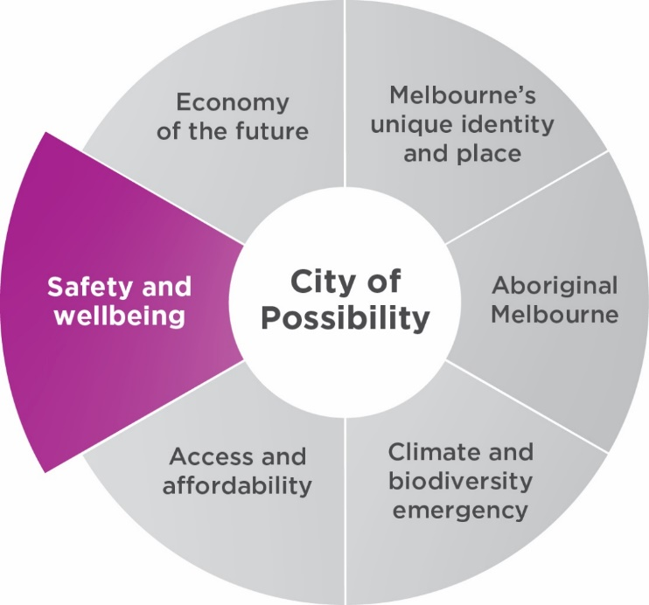

Our priorities
- All people feel safe and included when participating in Melbourne’s economic, visitor and community life. This priority aligns with, and contributes to, addressing our city's health and wellbeing focus areas.
- Bonds and social connections between individuals and communities of different backgrounds are strengthened. This priority aligns with, and contributes to, addressing our city's health and wellbeing focus areas.
- Enforce zero tolerance of violence in our community including family violence, violence against women, racism and discrimination in all forms. This priority aligns with, and contributes to, addressing our city's health and wellbeing focus areas.
- People are supported and encouraged to make healthy and sustainable lifestyle decisions. This priority aligns with, and contributes to, addressing our city's health and wellbeing focus areas.
- An efficient and safe transport network where our streets are safer for all users. This priority aligns with, and contributes to, addressing our city's health and wellbeing focus areas.

Major initiatives

Major initiative 45
Continue to implement the Transport Strategy 2030, including delivery of a protected bike lane network, station precincts as key gateways, little streets as streets for people, safer speed limits, micro mobility trials, more efficient traffic signal timing, developing an approach to support electric vehicles, and bicycling encouragement programs.

Council’s role
Deliver
Partner
Advocate

Activities for 2022–23 will include
- Developing a policy on low-emission vehicles.
- Delivering a bicycle encouragement program including workshops, training, communications, community development and events.
- Continuing micro-mobility trials (for example, e-scooters), including evaluation.
- Delivering new bike infrastructure including bike lanes on Arden Street, Albert Street, Queensberry Street, Macaulay Road and St Kilda Road.
- Improving East Melbourne pedestrian access.
- Implementing the recommendations of the independent transport review (commissioned by the City of Melbourne to assess transport activity in the city, and to identify actions to support post-pandemic recovery) including ongoing monitoring of traffic hotspots.

Governance and milestones
- Quarter 2: Council consideration of the draft low emissions vehicle policy.
- Quarter 2: Bicycle encouragement program launch.
- Quarter 3: Council consideration of micro-mobility trial evaluation and next steps.

Outcomes
- Lower transport emissions.
- Clear decision-making framework regarding electric vehicle infrastructure.
- Traffic movements across the city are well-balanced and planned to ensure commercial and passenger motor vehicles, bicycles, scooters and pedestrian movements are safe, effective and efficient.

Related Council Plan indicators of success
- Increase in proportion of trips made by public transport, bicycle or on foot.
- Decrease in number of transport related injuries and fatalities.
- Increase in capital gross local product.
- Decrease in on-road transport emissions.

Related Sustainable Development Goals
Sustainable Development Goal number 3 – Good Health and Well-being
Sustainable Development Goal number 8 – Decent Work and Economic Growth
Sustainable Development Goal number 9 – Industry, Innovation and Infrastructure
Sustainable Development Goal number 11 – Sustainable Cities and Communities

Major initiative 46
Deliver the North and West Melbourne and Docklands Transport and Amenity Program in partnership with the Victorian Government.

Council’s role
Deliver
Partner

Activities for 2022–23 will include
- Commencing delivery of a range of streetscape and public realm projects to address impacts and opportunities arising from the Victorian West Gate Tunnel Project.
- Spencer Street Masterplan: Spencer Street (North) between La Trobe St and Dynon Road including a range of projects for delivery in 2023–24 and 2025–26.
- Hawke Street Linear Park: Design of a linear park, with associated traffic calming measures and new protected cycle lanes on Hawke Street in West Melbourne.
- Franklin Street streetscape improvements. Design of a new linear open space connecting Metro Tunnel’s new State Library Station with Market Square, Queen Victoria Market.

Governance and milestones
- Quarter 3: Council consideration of Spencer Street Masterplan community engagement report
- Quarter 4: Council consideration of Franklin Street streetscape improvement community engagement report.
- Quarter 4: Council decision on Hawke Street Linear Park tender award.

Outcomes
- All projects are on track for completion in future years to achieve improvements in streetscapes and the public realm.

Related Council Plan indicators of success
- Decrease in number of transport related injuries and fatalities.
- 27 per cent tree canopy cover in the public realm.

Related Sustainable Development Goals
Sustainable Development Goal number 3 – Good Health and Well-being
Sustainable Development Goal number 15 – Life on Land

Major initiative 47
As part of the delivery of the City Road Master Plan, the City of Melbourne will design and deliver the upgrades to the City Road northern undercroft by end of 2023–24 and advocate to the Victorian Government for the full delivery of upgrades to the City Road East and West.

Council’s role
Deliver
Advocate

Activities for 2022–23 will include
- Completing the design, planning approval and tender award for the upgrades to the City Road northern undercroft and City Road Park.
- Commencing construction on the above.
- Continuing to advocate to the Victorian Government for upgrades to City Road East and West by undertaking further traffic studies.

Governance and milestones
- Quarter 3: Council consideration and decision on award of tender for the northern undercroft.
- Submission of materials to the Victorian Government for funding.

Outcomes
- Increased access to public open space, urban forest and recreation in Southbank.
- Improved safety and amenity for all users around City Road East and West.

Related Council Plan indicators of success
- Increase in proportion of residents within 300 metres of public open space.
- Decreased number of transport related injuries and fatalities.

Related Sustainable Development Goals
Sustainable Development Goal number 3 – Good Health and Well-being
Sustainable Development Goal number 9 – Industry, Innovation and Infrastructure
Sustainable Development Goal number 11 – Sustainable Cities and Communities

Major initiative 48
Adopt in 2021–22 and then implement an Inclusive Melbourne Strategy that will increase access to opportunities for all people and outline how the City of Melbourne will respond to the diversity of religions, cultures, age groups, gender, sexual orientation and ability among the people who live, work, study in and visit the city.

Council’s role
Deliver

Activities for 2022–23 will include
- Delivering immediate priorities from the Inclusive Melbourne Strategy.
- Creating foundations and compiling data that will help with monitoring progress towards strategic goals.
- Increasing access and inclusion in recreation and community services.
- Ensuring our information meets web content accessibility guidelines.
- Applying inclusive recovery principles in our decision-making, so vulnerable members of the community are not left behind as we continue to adapt to COVID-19.

Governance and milestones
- Quarter 2: Council consideration of the progress of delivery on the Inclusive Melbourne Strategy.
- Quarter 4: Effectiveness of the Community and Street Gardens policies reviewed, including consideration of whether these should be amended or replaced.

Outcomes
- City of Melbourne projects, programs and services are more focused on inclusion.

Related Council Plan indicators of success
- Melburnians’ self-reported sense of belonging to community is at least 70 on a scale of 100.
- Increased proportion of people support the city being made up of different cultures.

Related Sustainable Development Goals
Sustainable Development Goal number 3 – Good Health and Well-being
Sustainable Development Goal number 8 – Decent Work and Economic Growth
Sustainable Development Goal number 9 – Industry, Innovation and Infrastructure
Sustainable Development Goal number 10 – Reduced Inequalities
Sustainable Development Goal number 11 – Sustainable Cities and Communities

Major initiative 49
We will be a leading organisation on equality and inclusion, and deliver programs in communities that will reduce physical and psychological harm to all people. We will adopt and deliver the Prevention of Violence Against Women Action Plan (endorsed as the Women’s Safety and Empowerment Action Plan) 2021–24, and meet our obligations under the Gender Equality Act 2020.

Council’s role
Deliver

Activities for 2022–23 will include
- Delivering our obligations under the Gender Equality Act 2020 and implementing first year actions of our Gender Equality Action Plan.
- Conducting gender impact assessments on all new policies, programs and services.
- Developing and implementing year two actions of the Women’s Safety and Empowerment Action Plan.

Governance and milestones
- Quarter 3: Council consideration of the third-year actions in the Women’s Safety and Empowerment Action Plan
- Quarter 4: Council consideration of the report of progress on City of Melbourne obligations under the Gender Equality Act 2020.

Outcomes
- Increased awareness of, and commitment to, embedding equality and inclusion into everyday work at City of Melbourne.
- Womens’ Safety and Empowerment Plan Action Plan is incorporated within a coordinated and streamlined approach to inclusion at City of Melbourne.

Related Council Plan indicators of success
- 90 per cent and 65 per cent of people report feeling safe in the city during the day, and at night, respectively.
- Decrease in rate of recorded family violence incidents.

Related Sustainable Development Goals
Sustainable Development Goal number 5 – Gender Equality
Sustainable Development Goal number 16 – Peace, Justice and strong Institutions

Major initiative 50
We will continue to work with Victoria Police and other agencies to deliver a range of initiatives that improve safety on the streets of Melbourne and within our communities.

Council’s role
Deliver
Partner

Activities for 2022–23 will include
- Establishing a baseline understanding of the community’s perceptions of safety, and improving the City of Melbourne’s ability to track and measure these perceptions into the future.
- Developing a coordinated response program with Victoria Police to address safety issues.
- Engaging with communities in the development of neighbourhood plans to provide input to other initiatives that address safety concerns in communities.

Governance and milestones
- Implementation of initiatives throughout the year with quarterly reports to councillors and community.
- Partnership with Victoria Police on safety issues and implementation of initiatives.

Outcomes
- Perception of safety on streets has improved as a result of street cleaning and other amenity improvement initiatives.

Related Council Plan indicators of success
- 90 per cent and 65 per cent of people report feeling safe in the city during the day, and at night, respectively.

Related Sustainable Development Goal
Sustainable Development Goal number 16 – Peace, Justice and strong Institutions

Major initiative 51
Deliver and maintain a clean city through the Rapid Response Clean Team initiative.

Council’s role
Deliver

Activities for 2022–23 will include
- Developing a Graffiti Prevention Program
- Removing graffiti from heights and enhancing the footpath washing program.
- Maintaining city cleanliness through the Rapid Response Clean Team and delivering an associated public communication campaign during the city recovery and reactivation period.

Governance and milestones
- Quarter 3: Review of Rapid Response Clean Team service and planning for year three.
- Quarter 3: Council consideration of new Graffiti Prevention Program.

Outcomes
- 95 per cent reduction of visible graffiti tagging removed across municipality.
- Minimum 5 per cent improvement in community perception of city cleanliness.
- 90 per cent of street cleaning requests resolved within four operational hours.

Related Council Plan indicators of success
- 90 per cent and 65 per cent of people report feeling safe in the city during the day, and at night, respectively.

Related Sustainable Development Goal
Sustainable Development Goal number 16 – Peace, Justice and strong Institutions

Major initiative 52
Engage and prepare residents and communities to enhance their resilience to hazards, disasters and the health impacts of climate change.

Council’s role
Deliver

Activities for 2022–23 will include
- Identifying and promoting disaster resilience volunteer opportunities for City of Melbourne staff
- Incorporating resilience profiles and proposed actions into neighbourhood plans, informed by an assessment of community vulnerability.
- Developing and piloting capacity building and engagement to better prepare communities for climate hazards and risks.
- Developing relationships with resilience organisations and networks.

Governance and milestones
- Quarter 2: Resilience profiles and actions incorporated into online neighbourhood plans, considering community vulnerability (informed by Hazard Vulnerability Assessment for selected neighbourhoods)
- Quarter 3: Council consideration of community behavioural change and capacity building program.

Outcomes
- Increased capacity in disaster preparedness for relevant City of Melbourne staff, community leaders and businesses, as well as increased awareness of disasters (before, during and after).

Related Council Plan indicators of success
- Decrease in hospital admissions in relation to extreme weather events.

Related Sustainable Development Goals
Sustainable Development Goal number 1 – No Poverty
Sustainable Development Goal number 11 – Sustainable Cities and Communities

https://participate.melbourne.vic.gov.au/
https://www.melbourne.vic.gov.au/community/health-support-services/health-services/pages/municipal-public-health-and-wellbeing-plan.aspx
https://www.melbourne.vic.gov.au/about-council/vision-goals/Pages/council-plan.aspx
https://www.melbourne.vic.gov.au/about-council/vision-goals/Pages/united-nations-sustainable-development-goals.aspx

